# Top 10 Agile Metrics for Managing Scrum-Based Software Development Projects

**Published on 30 April 2025 at 14:28**

**Author: Kimberly Wiethoff**

Welcome to our comprehensive guide on the top Agile metrics that can transform your Scrum-based software development projects. As the Agile landscape continues to evolve, measuring the right things becomes increasingly critical for success.

When managing Agile software development projects using Scrum, it’s not enough to just hold the ceremonies and move tickets across a board. True Agile success requires actionable insights—and that’s where Agile metrics come in. These metrics serve as a compass, guiding Scrum teams to deliver value faster, identify blockers, and continuously improve.

Below are the top 10 Agile metrics every Scrum Master, Product Owner, and Agile Project Manager should monitor to keep development on track and teams thriving.

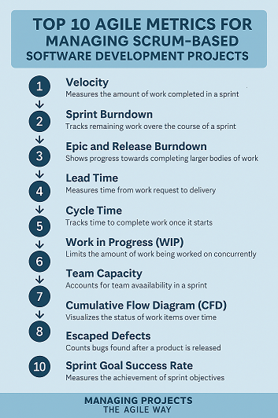

## 1. Velocity

Velocity measures the amount of work (typically in story points) a team completes during a sprint. It helps in forecasting how much work the team can handle in future sprints and supports sprint planning.

**Why it matters:** Establishes a delivery rhythm and helps predict future sprint capacities.

## 2. Sprint Burndown

The Sprint Burndown chart shows how much work remains in a sprint, ideally trending toward zero. It helps identify whether the team is likely to complete all planned work within the sprint.

**Why it matters:** Offers real-time visibility into sprint progress and early warnings of slippage.

## 3. Epic and Release Burndown

While sprint burndown focuses on short-term progress, Epic and Release Burndown charts track progress toward completing larger initiatives or releases.

**Why it matters:** Ensures transparency on long-term goals and helps manage stakeholder expectations.

## 4. Lead Time

Lead time measures the total time from when a story is added to the backlog until it’s completed and delivered. It reflects overall process efficiency.

**Why it matters:** Shorter lead times indicate quicker delivery and a smoother flow of work.

## 5. Cycle Time

Cycle time is a subset of lead time. It measures how long a story takes to complete once it enters development. Unlike lead time, it excludes backlog waiting time.

**Why it matters:** Identifies bottlenecks in the development process and supports flow-based improvements.

## 6. Work in Progress (WIP)

This metric tracks the number of stories or tasks actively being worked on at any given time. Scrum encourages limiting WIP to avoid context switching and overloading teams.

**Why it matters:** Enforces focus and improves flow efficiency by reducing multitasking.

## 7. Team Capacity: Realistic Sprint Planning

Capacity planning accounts for the team’s availability in a sprint (e.g., vacations, holidays, etc.) and adjusts commitments accordingly.

**Why it matters:** Prevents overcommitment and aligns velocity with real availability.

## 8. Cumulative Flow Diagram (CFD)

A CFD visualizes the status of work items (e.g., To Do, In Progress, Done) over time. It helps identify flow issues, bottlenecks, and WIP trends.

**Why it matters:** Provides a holistic view of workflow health and progress consistency.

## 9. Escaped Defects

This tracks the number of bugs or defects reported after release. A high number may indicate gaps in testing or poor quality assurance practices during development.

**Why it matters:** Keeps quality in focus and helps teams improve definition of done.

## 10. Sprint Goal Success Rate

This measures how often the team achieves the goal they committed to during sprint planning. It goes beyond task completion and evaluates value delivery.

**Why it matters:** Encourages outcomes over outputs and promotes product alignment.

## Final Thoughts

Agile metrics aren’t just numbers—they’re insights. When used consistently and reviewed with the team, these metrics foster a culture of continuous improvement, better predictability, and increased delivery confidence. Remember, the goal isn’t to micromanage but to guide the team toward sustainable, high-quality delivery.

Start small: pick 3–5 of these metrics and begin tracking them in your next sprint. As your team matures, evolve your measurement approach to support the ever-growing demand for value-driven software development.

**#AgileMetrics, #ScrumMetrics, #SprintBurndown, #Velocity, #LeadTime, #CycleTime, #CumulativeFlow, #Throughput, and #WIPLimits #AgileProjectManagement, #ScrumMaster, #AgileDevelopment, #SoftwareDevelopment, #DevOps, and #ContinuousImprovement. For those focused on team performance and delivery outcomes, use #TeamPerformance, #ProductivityMetrics, #AgileKPIs, #ProjectSuccess, and #AgileTransformation #AgileInsights, #AgileBestPractices, #AgileLeadership, #AgileCoaching, and #ScrumTips**