How to Study for and Pass the Certified Lean Management Professional Exam
Published on 7 March 2025 at 13:23
Author: Kimberly Wiethoff

If you're looking to advance your career in process improvement, efficiency, and operational excellence, earning the Certified Lean Management Professional (CLMP) credential can be a game-changer. This certification validates your expertise in Lean principles and continuous improvement methodologies, making you a valuable asset in any industry.
In this post, I’ll cover everything you need to know about preparing for and passing the CLMP exam, including costs, where to take the test, and the key topics to study.
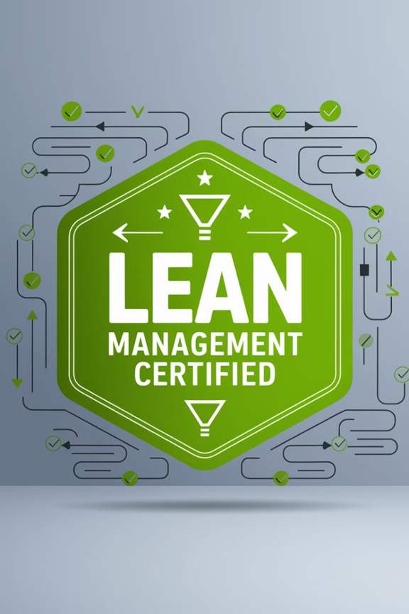

What Is the Certified Lean Management Professional (CLMP) Certification?
The Certified Lean Management Professional (CLMP) certification is designed for professionals who want to master Lean principles, identify waste, and drive efficiency in business processes. It covers Lean tools, Kaizen, value stream mapping, and other essential methodologies.
Who Should Take the CLMP Exam?
This certification is ideal for:
- Project Managers
- Operations Managers
- IT and Business Process Professionals
- Manufacturing and Supply Chain Specialists
- Consultants focused on Process Improvement
How Much Does the CLMP Exam Cost?
The cost of the CLMP exam varies by provider. Here’s a general breakdown of what you can expect:
- Exam Fee: $200 - $500 (varies by provider and location)
- Study Materials: $50 - $300 (books, courses, online training)
- Training Programs (optional): $300 - $1,500 (if you take an instructor-led course)
Many organizations offer discounts for members or group enrollments, so check if your employer will cover the cost as part of professional development.
Where Can You Take the CLMP Exam?
The CLMP certification is offered by multiple Lean and Six Sigma training providers. Some of the most well-known organizations include:
- Management and Strategy Institute (MSI) – Offers an online exam and self-paced training.
- Six Sigma Institute (SSI) – Provides Lean certification programs and exams.
- American Society for Quality (ASQ) – While ASQ primarily focuses on Six Sigma, they also offer Lean certifications.
Most providers offer online proctored exams, allowing you to take the test from home, but some also offer in-person testing at partner locations.
Topics Covered in the CLMP Exam
To pass the CLMP exam, you’ll need a strong understanding of Lean principles and how to apply them. Here are the key topics you should focus on:
1. Introduction to Lean Management
- History of Lean
- Core Lean Principles (Value, Value Stream, Flow, Pull, and Perfection)
- Lean vs. Six Sigma
2. Types of Waste (Muda, Mura, Muri)
- Identifying the 8 Wastes (DOWNTIME: Defects, Overproduction, Waiting, Non-utilized Talent, Transportation, Inventory, Motion, Extra Processing)
- Strategies for waste elimination
3. Kaizen & Continuous Improvement
- The PDCA Cycle (Plan, Do, Check, Act)
- How to implement Kaizen events
- Role of leadership in continuous improvement
4. Lean Tools and Techniques
- 5S (Sort, Set in Order, Shine, Standardize, Sustain)
- Value Stream Mapping (VSM)
- Just-in-Time (JIT) and Kanban Systems
- Standard Work and Work Balancing
5. Problem Solving and Root Cause Analysis
- The 5 Whys technique
- Fishbone (Ishikawa) Diagram
- Failure Mode and Effects Analysis (FMEA)
6. Lean Metrics and Performance Measurement
- Key Performance Indicators (KPIs) for Lean
- Cycle Time, Lead Time, and Takt Time
- Overall Equipment Effectiveness (OEE)
Study Tips for Passing the CLMP Exam
Here are some practical study strategies to help you prepare effectively:
1. Take an Online Course
Many training providers offer structured courses that cover all the exam topics. Platforms like Coursera, Udemy, and LinkedIn Learning provide affordable Lean Management courses.
2. Use Official Study Materials
If your exam provider offers an official study guide, use it as your primary resource. Books like Lean Thinking by James Womack and The Toyota Way by Jeffrey Liker are also great references.
3. Practice with Sample Questions
Many certification providers offer sample exams or practice questions. Websites like Six Sigma Study Guide and GoLeanSixSigma.com have practice tests that can help you assess your readiness.
4. Join a Lean Study Group or Community
Engage in Lean forums, LinkedIn groups, or local networking events to discuss Lean concepts with professionals who have taken the exam.
5. Apply Lean in Real Life
If possible, practice Lean concepts in your workplace. Identify waste in your current processes, create a value stream map, or implement 5S to reinforce your learning.
What’s Next After Passing the CLMP Exam?
Once you earn your Certified Lean Management Professional credential, consider these next steps:
- Apply Lean Principles – Use your knowledge to improve workflows and efficiency in your organization.
- Pursue Advanced Certifications – If you want to deepen your expertise, consider a Lean Six Sigma Green Belt or Black Belt certification.
- Showcase Your Certification – Add CLMP to your LinkedIn profile and resume to highlight your expertise.
Final Thoughts
Earning the Certified Lean Management Professional (CLMP) certification can give you a competitive edge in project management, operations, and process improvement. With the right study approach and practical experience, you’ll be well-prepared to pass the exam and leverage Lean methodologies in your career.
Have you taken the CLMP exam? Share your experience in the comments below!
#LeanManagement #CLMP #LeanCertification #ProcessImprovement #ContinuousImprovement #Kaizen #LeanSixSigma #ProjectManagement #OperationalExcellence #Efficiency #LeanPrinciples #ProfessionalDevelopment #CareerGrowth #SixSigma #LeanThinking

Yes, there are several free resources available to help you prepare for the Certified Lean Management Professional (CLMP) exam. Here are some options to consider:
1. Council for Six Sigma Certification (CSSC) Free Training Materials The CSSC offers free Six Sigma training materials suitable for self-study. These comprehensive guides cover various Lean Six Sigma levels and can serve as valuable resources for understanding Lean principles. citeturn0search0
2. Simplilearn's Free Lean Management Practice Test Simplilearn provides a free Lean Management practice test designed to simulate the actual certification exam. This resource can help you assess your knowledge and readiness for the CLMP exam. citeturn0search1
3. Management and Strategy Institute (MSI) Free Lean Six Sigma Practice Tests MSI offers free practice tests for various Lean Six Sigma certification levels, including Black Belt and general Lean Six Sigma principles. These tests can help you gauge your understanding of Lean concepts and identify areas for improvement. citeturn0search2
4. Learn Lean Sigma's Free Lean Six Sigma Practice Tests Learn Lean Sigma provides a collection of free Lean Six Sigma practice tests covering different belt levels and topics. These tests are designed to help you assess your knowledge and boost your confidence before taking the official exam. citeturn0search3
5. Leanscape's Free Fundamentals of Lean Course Leanscape offers a free online course titled "Fundamentals of Lean," which provides an introduction to Lean principles and practices. This 90-minute course includes on-demand video lessons, quizzes, and a certificate upon completion. citeturn0search7
6. Reddit Discussions and Recommendations Engaging with communities on platforms like Reddit can provide additional insights and resources. For example, users have discussed downloadable study materials for Lean Six Sigma certifications, sharing links and recommendations. citeturn0search6
These resources can serve as valuable tools in your preparation for the CLMP exam, offering study materials, practice tests, and community support to enhance your understanding of Lean principles.

Here’s a list of frequently asked questions (FAQs) about the Certified Lean Management Professional (CLMP) exam, along with their answers:

General Questions About CLMP Certification
1. What is the Certified Lean Management Professional (CLMP) certification?
The CLMP certification validates expertise in Lean principles, waste reduction, and process improvement methodologies. It is designed for professionals looking to enhance efficiency and operational excellence in their organizations.
2. Who should take the CLMP exam?
The certification is ideal for project managers, operations managers, process improvement specialists, supply chain professionals, consultants, and anyone involved in business process optimization.
3. What are the benefits of earning the CLMP certification?
- Improved knowledge of Lean principles and tools
- Enhanced career prospects in process improvement and management
- Recognition as a Lean professional in various industries
- Ability to drive efficiency and cost savings in organizations
4. Is the CLMP certification recognized globally?
Yes, the certification is recognized across industries and countries, especially in manufacturing, healthcare, IT, and supply chain management.

Exam Preparation and Study Tips
5. What topics are covered in the CLMP exam?
The exam typically covers:
- Introduction to Lean Management
- The 8 Wastes (DOWNTIME)
- Kaizen and Continuous Improvement
- Lean Tools (5S, Value Stream Mapping, Kanban, etc.)
- Problem-Solving Techniques (5 Whys, Fishbone Diagram)
- Lean Metrics (Cycle Time, Lead Time, Takt Time)
6. What are some free resources to study for the CLMP exam?
There are several free study materials available, including:
- Council for Six Sigma Certification (CSSC) – Free Lean training materials
- Simplilearn – Free Lean Management practice tests
- Leanscape – Free online course on Lean fundamentals
- Learn Lean Sigma – Free practice tests
- Reddit and LinkedIn Groups – Community discussions and shared study resources
7. Are there any recommended books for studying Lean Management?
Yes, some highly recommended books include:
- The Toyota Way by Jeffrey K. Liker
- Lean Thinking by James P. Womack and Daniel T. Jones
- Lean Six Sigma for Dummies by John Morgan and Martin Brenig-Jones
8. How can I practice Lean concepts in real life?
You can apply Lean principles in your workplace by:
- Identifying inefficiencies in processes
- Using Value Stream Mapping to analyze workflows
- Implementing 5S (Sort, Set in Order, Shine, Standardize, Sustain)
- Applying Kaizen for continuous improvement

Exam Logistics and Costs
9. How much does the CLMP exam cost?
The exam typically costs between $200 and $500, depending on the provider. Additional costs may include training courses and study materials.
10. Where can I take the CLMP exam?
The exam is usually available online through training providers such as:
- Management and Strategy Institute (MSI)
- Six Sigma Institute (SSI)
- American Society for Quality (ASQ) (for Lean-related certifications)
11. Is the CLMP exam online or in-person?
Most providers offer online proctored exams, but some also provide in-person testing at authorized centers.
12. How long does the CLMP exam take?
The exam duration varies, but it is generally 60 to 90 minutes long, consisting of multiple-choice questions.
13. What is the passing score for the CLMP exam?
The required passing score depends on the provider but is typically around 70% to 80%.
14. How soon will I receive my certification after passing the exam?
Most organizations issue the certification immediately or within a few days after successfully passing the exam.

After Certification
15. What can I do after earning the CLMP certification?
After passing the exam, you can:
- Apply Lean principles in your job to improve efficiency
- Add the certification to your resume and LinkedIn profile
- Pursue more advanced certifications like Lean Six Sigma Green Belt or Black Belt
- Use your skills to lead Lean transformation initiatives in your organization
16. Does the CLMP certification expire?
Most Lean certifications do not have an expiration date, but it’s recommended to stay updated with Lean practices through continued learning and professional development.
17. Can I retake the CLMP exam if I fail?
Yes, most providers allow retakes, but some may charge a retest fee. Check with your exam provider for their specific policy.
18. Will this certification help me get a job?
Yes, many employers value Lean-certified professionals, especially in project management, operations, supply chain, healthcare, and IT. Adding CLMP to your resume can make you a stronger candidate for roles that require process improvement expertise.

