Kanban vs. Scrum: Choosing the Right Agile Path for Your Project
Published on 9 May 2025 at 08:46
Author: Kimberly Wiethoff
In today’s fast-paced project environments, Agile has become the dominant methodology for delivering value quickly and efficiently. Among Agile frameworks, Scrum and Kanban are the two most widely used. While they share similar goals—improving workflow, increasing transparency, and delivering value continuously—they approach these goals very differently.
So how do you know which one is right for your project? Let’s break down the core differences and help you choose the path that aligns with your team’s needs and your project’s nature.

Shared Agile Principles
Before diving into differences, it’s important to recognize that both Scrum and Kanban embrace these Agile fundamentals:
- Value Delivery – Prioritizing customer value above all
- Continuous Improvement – Incrementally refining processes
- Team Collaboration – Encouraging cross-functional teamwork
- Transparency – Providing visibility into all work processes
Each framework achieves these principles through different mechanisms.

Scrum Framework Overview
Scrum offers a highly structured framework built around defined roles and fixed-length development cycles:
- Defined Roles: Scrum Master, Product Owner, and Development Team each carry distinct responsibilities.
- Time-Boxed Iterations: Work is organized into 2–4 week sprints, locking in deliverables.
- Structured Ceremonies: Sprint Planning, Daily Stand-ups, Sprint Reviews, and Retrospectives offer rhythm and feedback loops.
- Metrics: Velocity and Burndown Charts help track progress.
Scrum is ideal for product development teams needing structure, predictability, and regular stakeholder feedback.

Understanding Scrum: Structure, Roles, and Sprints
Scrum is a highly structured Agile framework with defined roles, time-boxed events, and iterative development cycles known as sprints (typically 2–4 weeks). It includes roles such as:
- Scrum Master (process facilitator)
- Product Owner (stakeholder liaison and backlog manager)
- Scrum Team (cross-functional developers)
Work is pulled into a Sprint Backlog and committed to for the duration of the sprint, with ceremonies like Sprint Planning, Daily Stand-ups, Sprint Reviews, and Retrospectives baked into the process. Scrum is excellent for projects where:
- The scope may evolve but needs structured planning.
- Teams benefit from clear roles and fixed-length iterations.
- There is a high demand for stakeholder involvement and visibility.

Understanding Kanban: Flow, Flexibility, and Visualization
Kanban, on the other hand, is less prescriptive and focuses on visualizing workflow and limiting work in progress (WIP). It uses a Kanban board with columns like To Do, In Progress, In Review, and Done, allowing teams to see bottlenecks and optimize flow.
Key elements of Kanban include:
- Continuous delivery with no fixed-length sprints.
- No defined roles—existing team structure remains.
- WIP limits to reduce context switching and improve throughput.
Kanban is ideal for:
- Operational or support teams handling incoming requests.
- Projects with changing priorities or unpredictable workloads.
- Teams looking for incremental improvements without structural overhaul.

Kanban Framework Overview
Kanban emphasizes flow over iteration and is designed for flexibility and real-time visibility:
- Visualize Work: Use Kanban boards to represent tasks and their status.
- Limit WIP (Work in Progress): Prevent bottlenecks and reduce context switching.
- Manage Flow: Focus on smooth delivery and reducing cycle times.
- Continuous Delivery: No sprints—work flows continuously and priorities shift as needed.
- Metrics: Track Lead Time, Cycle Time, and Throughput for performance insights.
Kanban is often favored in service-based, operations, or support environments where priorities shift frequently.

Scrum vs. Kanban: A Head-to-Head Comparison
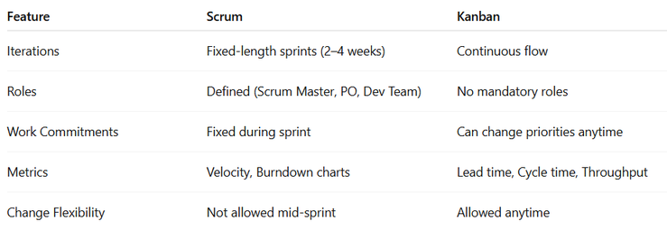

Which One Should You Choose?
Ask yourself these questions:
- Do we need structure and rhythm? Choose Scrum.
- Do we need flexibility and flow? Choose Kanban.
- Are we developing a product in iterative releases? Scrum works well.
- Are we managing ongoing work like service tickets or maintenance? Kanban fits better.
In some cases, teams even blend both frameworks, adopting Kanban's visual boards and WIP limits within a Scrum sprint cycle—often referred to as Scrumban.

Scrumban: The Hybrid Approach
Sometimes, teams blend both approaches into Scrumban to get the best of both worlds:
Scrumban is a hybrid Agile framework that blends the structure of Scrum with the flexibility of Kanban. It retains elements like sprint planning and some defined roles from Scrum while using Kanban’s visual boards and work-in-progress limits to manage flow. Scrumban is ideal for teams seeking the predictability of Scrum with the adaptability of continuous delivery.
- Time-Boxed Planning: Retain Sprint Planning but use Kanban flow.
- Kanban Boards: Visualize work across swim lanes.
- WIP Limits: Improve flow while retaining structure.
- Optional Roles: Use Scrum roles where they add value.
Scrumban is ideal for mature Agile teams seeking tailored practices.

How to Choose: Key Decision Factors
Consider these categories when deciding:
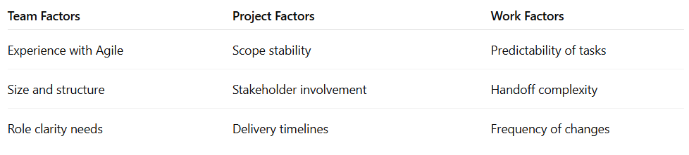

Implementation Roadmap
An implementation roadmap is a strategic plan detailing the activities, deliverables, roles, and timelines for deploying or enhancing a solution. It aligns goals, features, and initiatives with a clear process—from scope to budget—guiding the project from start to finish.
An implementation roadmap is vital in Scrum, Kanban, and Scrumban because it provides a structured approach to adopting the framework, aligning team roles, tools, and workflows with project goals. It ensures a smooth transition by setting clear expectations, defining metrics for success, and promoting team readiness—reducing confusion, minimizing disruption, and increasing the likelihood of long-term Agile adoption and value delivery.
- Assessment – Review work patterns, team readiness, and stakeholder needs.
- Preparation – Set up boards, define metrics, and provide Agile training.
- Implementation – Start small, inspect frequently, and adapt practices based on team feedback.

Measuring Success
Measuring success in Scrum and Kanban is essential to ensure teams are delivering value efficiently and continuously improving. By tracking key metrics—like velocity, cycle time, and team satisfaction—organizations gain visibility into performance, identify bottlenecks, and make data-driven decisions to enhance productivity, quality, and customer satisfaction.
Teams that implement Scrum or Kanban effectively often report:
- 20% Faster Delivery (reduced cycle times)
- 35% Quality Improvement (fewer defects)
- 40% Higher Team Satisfaction
- 25% Increase in Customer Satisfaction
Tracking these KPIs helps validate your Agile transformation.

Key Takeaways
- There’s no one-size-fits-all answer. Choose based on team, project, and workflow needs.
- Be ready to adapt and evolve as conditions change.
- Keep Agile principles at the core, regardless of the framework.
- Use data to measure success and guide improvement.
The right Agile path isn’t about following trends—it’s about understanding your context and empowering your team.

When to Choose Scrum, Kanban, or Scrumban
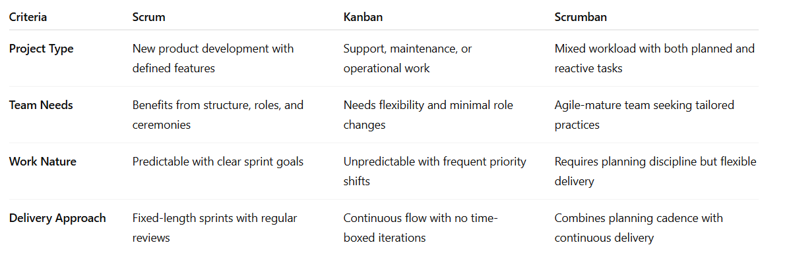

Final Thoughts
Your team’s size, maturity, project type, and workflow complexity all influence the best approach. The key is inspecting and adapting—the very heart of Agile. Whether you choose Scrum, Kanban, or a hybrid, staying focused on delivering value, improving transparency, and empowering your team will keep your project on the right path.
If you’re navigating the Agile landscape and choosing between frameworks, this guide can help you understand what fits best.

#KanbanVsScrum #AgileProjectManagement #KanbanFramework #ScrumMastery #AgileDelivery #ProjectManagementTips #WIPLimits #AgileLeadership #ContinuousImprovement #ManagingProjectsTheAgileWay

