Embracing Scrumban A Hybrid Approach to Agile Project Management
Published on 12 May 2025 at 14:16
By Kimberly Wiethoff
In the world of Agile project management, Scrum and Kanban often take center stage. Scrum brings structured sprints, roles, and ceremonies, while Kanban offers visual flow, flexibility, and continuous delivery. But what if your team needs a bit of both?
Enter Scrumban—a hybrid Agile framework that combines the discipline of Scrum with the flexibility of Kanban, designed to help teams improve delivery, manage shifting priorities, and continuously evolve.
Let’s break down what Scrumban is, why it’s gaining traction, and how project managers can leverage it for success.

🔹 What Is Scrumban?
Scrumban blends the structured sprint cycles and planning mechanisms of Scrum with the visual workflow and pull-based delivery of Kanban. Originally created to help Scrum teams transition to a more flow-based process, Scrumban has grown into a standalone framework ideal for evolving teams and hybrid project environments.
✅ Core Elements of Scrumban:
- No fixed-length sprints—work flows continuously
- Pull-based task management with Work-In-Progress (WIP) limits
- Optional Scrum ceremonies (daily stand-ups, retrospectives)
- Visual task tracking via a Kanban board
- Planning on demand rather than at set intervals

🔹 Why Choose Scrumban?
Scrumban is a great fit for teams that need structure without rigidity. It works especially well when:
- You’re juggling frequent changes in scope or priorities
- Projects involve ongoing maintenance and new feature delivery
- Your team struggles with the overhead of full Scrum ceremonies
- You want to improve flow and reduce bottlenecks
✅ Perfect for hybrid teams, product support, DevOps, or evolving Agile environments.

🔹 How Scrumban Combines the Best of Both Worlds
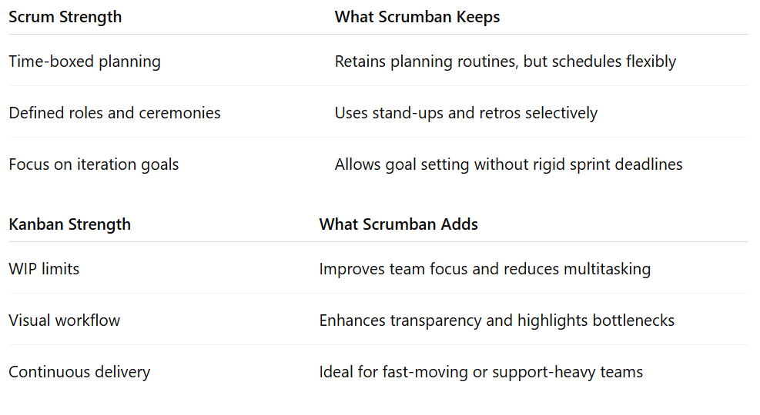

🔹 Key Practices to Implement Scrumban Successfully
- Visualize Work with a Kanban Board Map each stage of your process—from “To Do” to “Done”—and ensure everyone knows how to use it.
- Set WIP Limits Restrict how many tasks can be in progress at once. This prevents overload and encourages focus.
- Use “On-Demand” Planning Instead of sprint planning every two weeks, plan when capacity allows or the backlog grows.
- Hold Regular Stand-Ups and Retrospectives (as needed) Maintain visibility and continuous improvement without overloading the team with ceremonies.
- Track Metrics That Matter Focus on flow efficiency, cycle time, lead time, and throughput rather than velocity.

🔹 When to Use Scrumban
Scrumban works well when:
- Your team supports both project work and ongoing maintenance
- You’re in a transition phase between Scrum and Kanban
- You need real-time adaptability with minimal ceremony overhead
- The project requires rolling planning instead of fixed sprint cadences

🔹 Challenges to Watch For
Like any hybrid model, Scrumban comes with a learning curve. Common challenges include:
- Teams not enforcing WIP limits
- A lack of cadence causing communication gaps
- Poor backlog hygiene due to on-demand planning
✅ Tip: Pair Scrumban with good backlog grooming habits and a clear definition of done to maintain quality.

Final Thoughts
Scrumban offers a powerful, flexible approach for Agile teams navigating dynamic workloads and evolving priorities. By combining the structure of Scrum with the flow of Kanban, it empowers teams to stay focused, responsive, and continuously improving—without being bogged down by process.
Whether you're supporting multiple initiatives, scaling Agile in non-software teams, or seeking a better balance between planning and flexibility, Scrumban could be the Agile middle ground you’ve been looking for.

Hashtags (in paragraph form)
Looking for an Agile framework that fits your team’s real-world pace? Scrumban may be the answer. #Scrumban #AgileProjectManagement #HybridAgile #Kanban #Scrum #ProjectManagementTips #ContinuousImprovement #AgileFrameworks #ManagingProjectsTheAgileWay
Would you like a side-by-side Scrum vs. Kanban vs. Scrumban infographic to accompany this post?

