Tool Wars: Jira vs. Azure DevOps vs. Monday – Which Fits Your Agile Team?
Published on 13 May 2025 at 11:10
By Kimberly Wiethoff
Choosing the right Agile project management tool can make—or break—team productivity. From sprint planning to stakeholder reporting, your tool should be more than a ticket tracker; it should be a collaboration catalyst. But with dozens of platforms available, how do you choose the right one?
Three popular options—Jira, Azure DevOps, and Monday.com—often top the list. Each has strengths, weaknesses, and ideal use cases. In this blog, we break down the essentials to help you make a smart, strategic decision.

⚙️ Jira: The Customizable Giant
Best for: Software development teams needing detailed Agile configuration
Strengths:
- Built with Scrum and Kanban in mind
- Deep customization (workflows, issue types, automations)
- Powerful backlog management and reporting tools
- Strong plugin ecosystem (via Atlassian Marketplace)
Challenges:
- Steeper learning curve for non-technical users
- Can become complex and cluttered if not well maintained
💬 Pro insight: Jira is ideal for technical teams who want control over every aspect of their Agile process—but be prepared to invest time in setup and governance.

🔧 Azure DevOps: The Integrated DevOps Suite
Best for: Teams already using Microsoft products and CI/CD pipelines
Strengths:
- Seamless integration with Visual Studio, GitHub, and Microsoft 365
- Built-in boards, repos, pipelines, and test plans
- Excellent traceability from requirement to deployment
- Strong governance and permission control
Challenges:
- UI can feel clunky compared to modern tools
- May be too heavyweight for smaller teams or business units
💬 Pro insight: If you're already in the Microsoft ecosystem and need end-to-end DevOps support, Azure DevOps offers unmatched continuity.

🧩 Monday.com: The Visual Collaboration Platform
Best for: Cross-functional teams, marketing, operations, or non-technical departments
Strengths:
- User-friendly and highly visual UI
- Flexible workflows with drag-and-drop simplicity
- Great for high-level project visibility and stakeholder reporting
- Fast setup with minimal technical overhead
Challenges:
- Limited depth for technical Agile use cases (e.g., no native Git integration)
- Reporting and sprint planning tools are basic compared to Jira or ADO
💬 Pro insight: Monday is excellent for Agile-adjacent teams who want clarity, speed, and ease—not deep software dev integration.

📊 Feature Comparison Snapshot
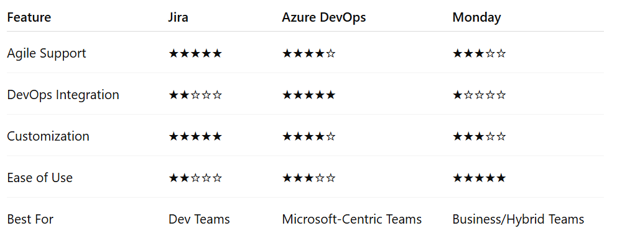

🔍 Which One Is Right for You?
Ask yourself:
- Are you managing developers, marketers, or mixed teams?
- Do you need heavy customization or lightweight flexibility?
- How important is integration with your existing toolset?
✅ The Agile way: Choose the right tool for the team, not the trend. Tools should support your process—not define it.

Final Thoughts
There’s no one-size-fits-all solution when it comes to Agile tools. Jira shines in customization, Azure DevOps wins in integration, and Monday excels in simplicity. Your decision should be based on your team’s workflow, tech stack, and stakeholder needs—not just buzzwords or brand names.
Remember, tools are only as effective as the team practices and culture they support.
🔗 Related Reads from ManagingProjectsTheAgileWay.com:
- Jira vs. Azure DevOps (ADO): Which Tool Should IT Managers Choose for Project Management
- Top 10 Agile Metrics for Managing Scrum-Based Software Development Projects
- 6 Practices: Kanban Rules of Engagement
#AgileTools #Jira #AzureDevOps #MondayCom #ProjectManagementTools #AgileProjectManagement #DevOps #ScrumTeams #ToolSelection #ProductivityTools #AgileWorkflow #AgileLeadership #ManagingProjectsTheAgileWay #PMTips

