How to Transition from Project Manager to Release Train Engineer (RTE) in SAFe
Published on 7 May 2025 at 13:19
Author: Kimberly Wiethoff
As organizations embrace Agile at scale, many project managers are finding themselves at a career crossroads. One of the most rewarding—and natural—transitions is moving into the role of Release Train Engineer (RTE) within the Scaled Agile Framework (SAFe).
But what exactly does this transition entail? How do your traditional project management skills map to the responsibilities of an RTE? And what steps can you take to prepare?
Let’s break it down.

🎯 What Is an RTE?
A Release Train Engineer (RTE) is the servant leader and coach of the Agile Release Train (ART)—a long-lived team of Agile teams (usually 5–12 teams) that work together to deliver value on a fixed cadence through Program Increments (PIs).
The RTE facilitates planning, execution, and continuous improvement, and acts as a cross-team coordinator and communication bridge across business, technology, and leadership stakeholders.

🧩 PM vs. RTE: What’s the Difference?
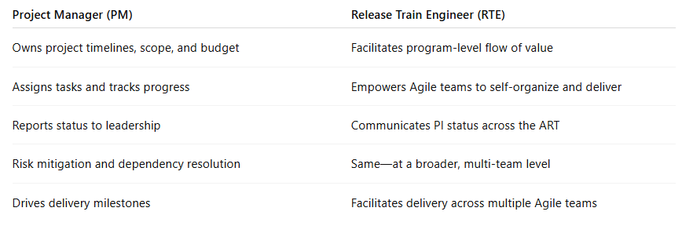
📌 Core takeaway: RTE is less directive and more about facilitation, coaching, and orchestration across teams.

🛠️ Transferable PM Skills That Map to RTE Success
Many project managers already have the foundational skills needed to become effective RTEs:
- Cross-team coordination: Juggling timelines and dependencies is second nature to PMs.
- Facilitation: If you’ve led retros, stakeholder meetings, or program reviews, you’re already halfway there.
- Risk management: Proactive identification and resolution of blockers are crucial for both roles.
- Status reporting: RTEs communicate progress, PI objectives, and delivery outcomes to leadership.
- Stakeholder engagement: Strong communication with business, technical, and leadership stakeholders is essential.

🧭 How to Start the Transition
If you're a PM interested in becoming an RTE, here are practical steps to make the leap:

1. Understand SAFe Inside and Out
Start with the SAFe 6.0 framework (from Scaled Agile Inc.). Learn about the layers—Team, Program, Large Solution, and Portfolio—and how they align.
📘 Recommended:
- SAFe for Teams course
- SAFe RTE Certification (SPC or RTE)

2. Attend or Facilitate PI Planning
Volunteer to help facilitate Program Increment (PI) Planning. Observe how teams plan together, identify dependencies, and set shared objectives.
Bonus: Offer to run the Scrum of Scrums or ART Syncs—you’ll get hands-on experience in aligning multiple teams.

3. Build Relationships with Agile Teams
Spend time learning how each team operates. RTEs thrive when they understand team dynamics, blockers, and delivery challenges at the ground level.

4. Practice Agile Metrics & Reporting
RTEs use flow metrics like predictability, throughput, cycle time, and PI burn-up charts to measure ART performance.
Get comfortable with tools like:
- Jira Align
- Azure DevOps
- Power BI or Tableau dashboards

5. Grow Your Coaching Muscle
An RTE is more coach than commander. Learn how to facilitate effective Inspect & Adapt workshops, problem-solving sessions, and system demos.

🚀 Final Thoughts
Transitioning from Project Manager to Release Train Engineer is one of the most valuable and future-forward moves you can make in a SAFe organization. The RTE role enables you to lead Agile at scale, improve cross-team delivery, and help organizations achieve real business agility.
It’s not about giving up control—it’s about gaining influence, alignment, and impact across the enterprise.
So if you're ready to trade your Gantt chart for a PI board, the RTE path might just be your next big leap.
#ReleaseTrainEngineer #SAFeFramework #AgileProjectManagement #CareerTransition #ScaledAgile #RTE #PIPlanning #AgileLeadership #ProjectManagerToRTE #ManagingProjectsTheAgileWay

