From Firefighting to Flow: How Lean Thinking Transforms Project Delivery
Published on 3 July 2025 at 12:44
By Kimberly Wiethoff - Managing Projects The Agile Way
If you've ever felt like your project team spends more time reacting than delivering, you're not alone. In many organizations, project managers are stuck in firefighting mode—rushing from one crisis to the next, solving problems as they explode, and barely catching their breath before the next deadline looms.
But what if we could shift from chaos to calm? From reactive to proactive?
That’s where Lean thinking comes in.

🔄 What Is Lean Thinking?
Originally rooted in manufacturing, Lean is a philosophy focused on delivering value by eliminating waste and improving flow. But Lean isn't just for assembly lines—it's a powerful lens through which project managers can view planning, execution, and collaboration.
At its core, Lean helps you:
- Identify and remove non-value-added activities
- Deliver more consistently and predictably
- Foster a culture of continuous improvement
- Shift the team’s focus from firefighting to flow

🚧 The Cost of Firefighting
Firefighting in projects might look like:
- Constantly reprioritizing tasks at the last minute
- Teams waiting on decisions or approvals
- Fixing defects that could have been avoided with better planning
- Spending hours in meetings with no clear action items
These are symptoms of process waste—or what Lean defines as:
- Waiting
- Overprocessing
- Defects
- Task switching
- Underutilized talent
And when left unchecked, they not only slow progress—they burn out teams.

🌊 Shifting Toward Flow
Flow in a project context means tasks move smoothly from initiation to completion with minimal friction. Lean helps create that flow by introducing tools and principles that remove bottlenecks and clarify priorities.
Here’s how Lean transforms common project challenges:
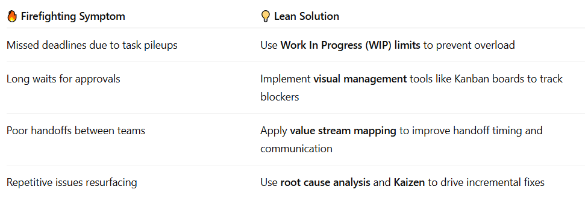

📈 Real-World Example: Lean in Action
At one healthcare tech company, we struggled with delivery delays caused by last-minute scope changes and inconsistent sprint commitments. Instead of pushing the team harder, we paused to take a Lean approach.
We mapped the value stream and discovered:
- Redundant review cycles were causing rework
- Stories were being pulled before requirements were clear
- Teams were overcommitted and context-switching too frequently
By limiting WIP, clarifying acceptance criteria early, and introducing daily flow metrics using Power BI, we saw:
- A 25% increase in delivery predictability
- A 15% reduction in rework
- Higher team morale and less burnout

🔧 Easy Lean Wins You Can Try This Week
- Visualize Your Work
Start with a basic Kanban board. Make blockers visible.
- Introduce a Daily Flow Metric
Track cycle time or lead time, not just velocity.
- Hold a Quick Kaizen
Ask: What’s one small change we can make this sprint to improve?
- Limit Work In Progress
Reduce context switching and focus on finishing.
- Map Your Value Stream
Sketch the journey of a user story from request to delivery. Where are the delays?

🧭 From Chaos to Calm: Leading the Shift
As project leaders, embracing Lean means modeling calm, thoughtful delivery over frantic heroics. It means creating systems where work flows, teams grow, and customers get what they need—on time and without drama.
You don’t need a full Lean transformation to make progress. Start small. Eliminate one source of waste. Celebrate one win.
And remember: sustainable delivery is built on flow, not fire drills.
💬 Have you tried Lean thinking in your projects? What helped you shift from firefighting to flow? Drop your thoughts or tips in the comments!
#ManagingProjectsTheAgileWay #LeanProjectManagement #ContinuousImprovement #AgileDelivery #LeanThinking #ProjectLeadership

