Unlocking Success Essential Soft Skills for Project Management
Published on 8 April 2024 at 10:45
Author: Kimberly Wiethoff

In the realm of project management, technical prowess and industry knowledge only take you so far. While these aspects are undoubtedly crucial, it's the soft skills that truly set exceptional project managers apart from the rest. Soft skills encompass a wide array of personal attributes, communication abilities, and interpersonal aptitudes that are essential for navigating the complex landscape of project management. Let's delve into some of the key soft skills that are indispensable for success in this dynamic field.
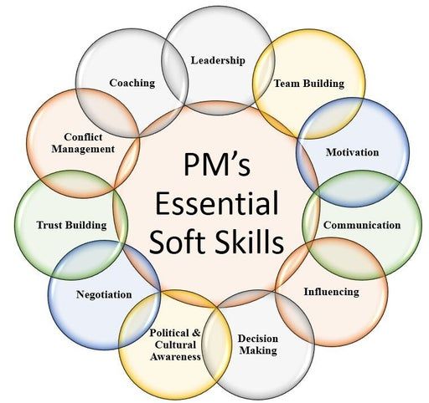

1. Communication
Effective communication lies at the heart of project management. A skilled project manager must be able to articulate ideas clearly, actively listen to stakeholders, and convey information in a manner that fosters understanding and collaboration. Whether it's leading team meetings, negotiating with clients, or resolving conflicts, strong communication skills are non-negotiable.

2. Leadership
Project managers are tasked with guiding teams towards a common goal, and strong leadership skills are paramount in achieving this objective. A great leader inspires trust, motivates team members, and empowers individuals to perform at their best. By providing clear direction, offering support, and leading by example, project managers can foster a culture of accountability and excellence within their teams.

3. Adaptability
In the fast-paced world of project management, change is inevitable. Project managers must possess the ability to adapt quickly to shifting priorities, unforeseen challenges, and evolving circumstances. Being adaptable means remaining flexible, resourceful, and resilient in the face of adversity, and being willing to adjust plans and strategies as needed to ensure project success.

4. Problem-Solving
Every project encounters obstacles along the way, and it's the responsibility of the project manager to navigate these challenges effectively. Strong problem-solving skills enable project managers to identify root causes, brainstorm creative solutions, and implement strategies to overcome hurdles. By approaching problems with a systematic and analytical mindset, project managers can keep projects on track and minimize disruptions.

5. Emotional Intelligence
Emotional intelligence, or EQ, is a critical soft skill for project managers, as it influences how they interact with others and navigate interpersonal dynamics. A high level of EQ enables project managers to understand their own emotions and those of others, manage conflicts constructively, and build strong relationships based on trust and mutual respect. By fostering a positive and supportive team environment, project managers can enhance collaboration and drive project success.

6. Time Management
Effective time management is essential for keeping projects on schedule and within budget. Project managers must be adept at prioritizing tasks, allocating resources efficiently, and setting realistic deadlines. By establishing clear timelines and milestones, monitoring progress closely, and proactively addressing potential delays, project managers can ensure that projects are completed on time and meet stakeholders' expectations.
7. Collaboration
Project management is inherently collaborative, requiring teamwork and cooperation across various departments and stakeholders. A skilled project manager fosters a spirit of collaboration by promoting open communication, encouraging knowledge sharing, and leveraging the diverse strengths of team members. By facilitating collaboration and synergy, project managers can harness the collective expertise of the team to drive innovation and achieve project objectives.
Final Thoughts
In conclusion, while technical skills are undoubtedly important in project management, it's the soft skills that truly distinguish exceptional project managers. By honing their communication abilities, leadership qualities, adaptability, problem-solving skills, emotional intelligence, time management techniques, and collaborative mindset, project managers can navigate the complexities of project management with finesse and achieve outstanding results. So, aspiring project managers, take note: mastering these soft skills is the key to unlocking success in the ever-evolving world of project management.

