Personality Tests for Job Seekers Comparing DiSC and the Top 5 Alternatives
Published on 24 September 2025 at 11:12
By Kimberly Wiethoff, MBA, PMP, PMI-ACP
When searching for the right career path or preparing for interviews, personality assessments can be a powerful tool. While the DiSC Assessment is one of the most popular, it isn’t the only option. Depending on your goals—whether understanding strengths, improving teamwork, or aligning with organizational culture—you may find that one of the alternatives better fits your needs. Below we explore five of the top alternatives to DiSC and how they can help in finding a job.
Let’s break down DiSC first, and then compare it with the top alternatives.

The DiSC Assessment
The DiSC Assessment is one of the most widely used workplace tools, but it’s not the only option. Depending on your goals, you might find other personality frameworks—like StrengthsFinder, TeamDynamics, MBTI, the Big Five, or the Enneagram—better suited to your job search strategy.
- What it measures: Four core behavioral styles—Dominance (D), Influence (I), Steadiness (S), and Conscientiousness (C).
- Why it’s useful: DiSC reveals how you communicate, solve problems, and collaborate with others. It’s particularly valuable in team-based or client-facing roles where communication style can make or break success.
- Best for job seekers who want to: Highlight adaptability, explain how they interact with teams, and position themselves as effective collaborators.
- Example job search application: In an interview, someone with a “High S” profile might emphasize patience, loyalty, and dependability, while a “High D” might focus on decisiveness and results.

What it measures
The DiSC framework categorizes workplace behavior into four core styles:
- Dominance (D) – Decisive, results-driven, strong-willed, and direct.
- Influence (I) – Outgoing, persuasive, energetic, and enthusiastic communicators.
- Steadiness (S) – Patient, dependable, team-oriented, and cooperative.
- Conscientiousness (C) – Detail-oriented, analytical, cautious, and quality-focused.
Each individual typically shows a blend of these traits, with one or two being dominant.

Why it’s useful for job seekers
- Helps you understand and communicate your workplace behavior style, which is crucial in interviews and team discussions.
- Allows you to adapt your communication style to connect better with interviewers, hiring managers, and colleagues.
- Provides concrete language to describe collaboration and leadership style (e.g., “I bring steadiness and reliability to high-pressure teams”).

Domains or Style Categories
DiSC maps onto two primary axes:
- Assertiveness vs. Supportiveness
- Task Focus vs. People Focus
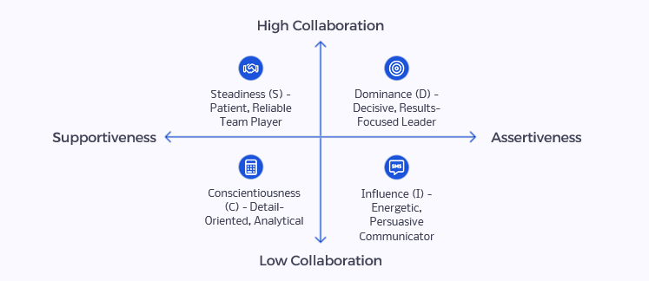
This creates four quadrants that explain natural tendencies toward leadership, collaboration, or problem-solving.

Best for job seekers who want to
- Showcase how they work on teams and manage workplace relationships.
- Emphasize adaptability in communication and collaboration.
- Prepare for interviews in industries where team fit and communication style are critical (e.g., consulting, sales, healthcare, project management).

Job Search Application Example
- A High D (Dominance) candidate might say:
“I thrive in roles that require decisive action and leadership. I focus on achieving results while ensuring the team stays aligned on priorities.”
- A High S (Steadiness) candidate might frame it as:
“I bring patience, consistency, and reliability to teams, which helps create a stable environment for collaboration and long-term success.”
✅ Compared to MBTI or Enneagram, which focus on inner preferences and motivations, DiSC is more outward-facing. It describes how your behavior shows up in the workplace, making it highly practical for interviews, team integration, and client-facing roles.

Alternative #1: StrengthsFinder (Gallup CliftonStrengths)
The CliftonStrengths (StrengthsFinder) assessment identifies 34 talent themes, which Gallup groups into four domains: Executing, Influencing, Relationship Building, and Strategic Thinking.
- What it measures: Identifies your top 5 strengths across 34 talent themes (e.g., Strategic, Achiever, Relator).
- Why it’s useful: Provides a positive, strength-based lens on your abilities, helping you articulate what you bring to the table in resumes and interviews.
- Best for job seekers who want to: Highlight their unique value, align strengths with job requirements, and boost confidence during interviews.
The CliftonStrengths (formerly StrengthsFinder) identifies your top 5 strengths out of 34 talent themes, grouped into four domains:
- Executing – Getting things done, driving performance.
- Influencing – Persuading, inspiring, and motivating others.
- Relationship Building – Building trust, collaboration, and strong teams.
- Strategic Thinking – Analyzing, planning, and imagining the future.
Instead of highlighting weaknesses, it emphasizes what you naturally do best and how to apply it.

Why it’s useful for job seekers
- Provides strength-based language for resumes, cover letters, and interviews.
- Builds confidence by focusing on your unique, natural talents.
- Helps align your career path with roles that leverage your strengths.
- Makes your “Tell me about yourself” answer more compelling.

Best for job seekers who want to
- Highlight unique value propositions in interviews.
- Translate natural talents into specific workplace contributions.
- Show employers confidence, focus, and self-awareness.

Job Search Application Example
- A candidate with Strategic in their Top 5 might say:
“I excel at seeing patterns and future opportunities, which helps me guide teams toward the best long-term solutions.”
- A candidate with Relator might frame it as:
“I build close, trusting relationships with colleagues, which creates strong collaboration and team cohesion.”
✅ Compared to DiSC, which focuses on workplace behaviors, StrengthsFinder emphasizes talent themes and natural abilities. It’s especially useful for interview preparation and personal branding since it gives you strengths-based language to position yourself with confidence.
Here’s the full list:

Executing Domain
(How you make things happen)
- Achiever
- Arranger
- Belief
- Consistency
- Deliberative
- Discipline
- Focus
- Responsibility
- Restorative

Influencing Domain
(How you influence others)
10. Activator
11. Command
12. Communication
13. Competition
14. Maximizer
15. Self-Assurance
16. Significance
17. Woo (Winning Others Over)

Relationship Building Domain
(How you build strong relationships)
18. Adaptability
19. Connectedness
20. Developer
21. Empathy
22. Harmony
23. Includer
24. Individualization
25. Positivity
26. Relator

Strategic Thinking Domain
(How you absorb and analyze information)
27. Analytical
28. Context
29. Futuristic
30. Ideation
31. Input
32. Intellection
33. Learner
34. Strategic

Most people discover their Top 5 themes, but the full report ranks all 34 in order of dominance. Employers and coaches often use these to help professionals align roles with natural talents.

Alternative #2: TeamDynamics
TeamDynamics focuses on how individuals contribute to a team, handle collaboration, and resolve conflict. Instead of labeling personality types in isolation, it looks at how different working styles interact in a group environment.
- What it measures: Evaluates how you work in teams—your collaboration style, communication approach, and potential blind spots.
- Why it’s useful: Many hiring managers want to know how well you’ll integrate into their team. This tool gives language to describe your teamwork style.
- Best for job seekers who want to: Demonstrate emotional intelligence, show adaptability, and explain how they add value in group settings.

The TeamDynamics framework typically evaluates:
- Collaboration style (how you prefer to work with others)
- Communication style (direct, supportive, detailed, big-picture, etc.)
- Decision-making approach (analytical vs. intuitive, fast vs. careful)
- Conflict style (avoidant, collaborative, competitive, etc.)
- Preferred team role (driver, supporter, innovator, coordinator, etc.)

Why it’s useful for job seekers
- Helps you explain how you fit into a team, which is often a key interview question.
- Provides language to describe how you collaborate, resolve conflict, and adapt to group dynamics.
- Demonstrates emotional intelligence (EQ)—a skill recruiters and hiring managers highly value.

Domains or Style Categories
TeamDynamics assessments usually sort people into team role archetypes, such as:
- Drivers – push projects forward, action-oriented
- Organizers – detail-focused, process-oriented
- Collaborators – relationship builders, supportive
- Visionaries – big-picture thinkers, innovators
- Analyzers – data-driven, cautious decision makers
(Some providers use slightly different naming conventions, but the essence is consistent: balancing results, relationships, creativity, and structure.)

Best for job seekers who want to
- Show that they understand team chemistry and where they add value.
- Stand out in industries where collaboration is critical (e.g., consulting, healthcare, tech, cross-functional projects).
- Prepare examples for interview questions like “Tell me about a time you worked on a team” or “How do you handle conflict?”

Job Search Application Example
If your TeamDynamics report shows you’re a Visionary, you might say in an interview:
“I naturally bring creative ideas and big-picture thinking to teams. I complement detail-oriented teammates by helping them see new opportunities, while relying on them to operationalize plans.”
✅ Compared to DiSC, which is also about workplace behavior, TeamDynamics is more team-role specific and emphasizes collaboration impact rather than just communication style.

Alternative #3: Myers-Briggs Type Indicator (MBTI)
The MBTI identifies personality preferences across four dichotomies, resulting in 16 possible personality types.
- What it measures: Personality preferences across four dichotomies (e.g., Introversion/Extraversion, Thinking/Feeling), producing 16 personality types.
- Why it’s useful: While MBTI isn’t predictive of performance, it helps you reflect on how you make decisions, process information, and communicate.
- Best for job seekers who want to: Improve self-awareness, frame personal stories in interviews, and understand preferred work environments.

The dichotomies are:
- Extraversion (E) vs. Introversion (I) – Where you get energy (outward from interaction vs. inward from reflection).
- Sensing (S) vs. Intuition (N) – How you gather information (practical details vs. big-picture patterns).
- Thinking (T) vs. Feeling (F) – How you make decisions (logic-driven vs. values/people-driven).
- Judging (J) vs. Perceiving (P) – How you approach structure (organized and planned vs. flexible and adaptable).
Example types include INTJ (The Strategist) or ESFP (The Entertainer).

Why it’s useful for job seekers
- Provides a framework for self-awareness—understanding how you make decisions, solve problems, and interact with others.
- Helps you prepare for behavioral interview questions (e.g., how you handle ambiguity, conflict, or structure).
- Useful for exploring preferred work environments—structured vs. flexible, collaborative vs. independent.

Domains or Style Categories
MBTI sorts people into 16 types, which are often grouped into 4 bigger categories:
- Analysts (e.g., INTJ, ENTJ, INTP, ENTP) – Strategic, logical, innovative thinkers.
- Diplomats (e.g., INFJ, ENFJ, INFP, ENFP) – Empathetic, values-driven, people-focused.
- Sentinels (e.g., ISTJ, ESTJ, ISFJ, ESFJ) – Organized, dependable, tradition-oriented.
- Explorers (e.g., ISTP, ESTP, ISFP, ESFP) – Flexible, spontaneous, practical problem solvers.

Best for job seekers who want to
- Improve self-awareness to describe strengths and work preferences.
- Identify potential growth areas (e.g., introverts practicing networking, perceivers working on deadlines).
- Explore careers that align with personality type (e.g., INFJs may gravitate toward coaching/mentorship roles, ESTJs toward management).

Job Search Application Example
If you’re an ENTP, you might say in an interview:
“I thrive in dynamic environments where I can brainstorm new solutions, adapt quickly, and influence others to try innovative approaches.”
✅ Compared to DiSC, MBTI is broader and focuses on cognitive preferences rather than observable behaviors. It’s not predictive of job success, but it helps with career reflection, storytelling, and workplace fit.

Alternative #4: The Big Five Personality Traits (Five Factor Model)
The Big Five is one of the most scientifically validated frameworks in psychology. It measures personality across five broad dimensions (often remembered by the acronym OCEAN):
- What it measures: Five core traits—Openness, Conscientiousness, Extraversion, Agreeableness, and Neuroticism (OCEAN).
- Why it’s useful: Research-backed and widely used by employers, especially for roles where conscientiousness and emotional stability are critical.
- Best for job seekers who want to: Prepare for pre-employment personality tests, show data-driven awareness of workplace behaviors, and align with evidence-based hiring practices.

5 Broad Dimension
- Openness to Experience – Creativity, curiosity, comfort with change and new ideas.
- Conscientiousness – Organization, reliability, attention to detail, goal orientation.
- Extraversion – Sociability, assertiveness, and energy from interaction.
- Agreeableness – Cooperation, empathy, trust, and concern for others.
- Neuroticism (Emotional Stability) – Tendency toward stress, anxiety, or emotional resilience.
Each trait is measured on a spectrum rather than a type, making it more nuanced than MBTI or DiSC.

Why it’s useful for job seekers
- Many employers use Big Five-based assessments in hiring because it has strong predictive validity for job performance.
- Provides insight into workplace strengths (e.g., high conscientiousness → strong reliability, low neuroticism → calm under pressure).
- Helps identify fit for certain roles:
  - High Openness → creative or innovative industries.
  - High Conscientiousness → structured, detail-driven roles like project management.
  - High Extraversion → sales, leadership, or public-facing roles.
  - High Agreeableness → customer service, HR, or team-oriented careers.
  - Low Neuroticism (high stability) → high-pressure jobs like emergency response or executive leadership.

Domains or Style Categories
Unlike other tests, the Big Five doesn’t assign a “type.” Instead, it maps your position on a spectrum for each trait. This makes it more flexible and realistic, since no one is 100% one way or the other.

Best for job seekers who want to
- Prepare for pre-employment screening (many companies use OCEAN-based tests).
- Showcase data-backed traits in resumes and interviews (e.g., “I bring high conscientiousness and reliability to my projects”).
- Understand which job environments might align better with their natural tendencies.

Job Search Application Example
If your results show high Conscientiousness and low Neuroticism, you might say:
“I’m known for being dependable and level-headed under pressure, which makes me well-suited to manage complex projects and deliver results consistently.”
✅ Compared to DiSC, which is more about communication and behavior, the Big Five is research-driven and often used in actual hiring processes. It’s less about labels and more about measurable tendencies.

Alternative #5: Enneagram
The Enneagram describes nine core personality types, each with unique strengths, fears, and motivations. Unlike some assessments that focus on behavior (DiSC) or cognitive preferences (MBTI), the Enneagram digs into underlying drivers that influence decision-making and interpersonal dynamics.
- What it measures: Nine core personality types that reveal motivations, fears, and growth paths.
- Why it’s useful: Goes deeper into values and motivators, helping you identify roles and company cultures that fit your personality.
- Best for job seekers who want to: Explore long-term career alignment, understand intrinsic motivators, and frame personal development stories.

The nine types are:
- The Reformer (Perfectionist) – Principled, responsible, seeks improvement.
- The Helper – Caring, supportive, motivated by a need to be needed.
- The Achiever – Success-oriented, adaptable, image-conscious.
- The Individualist – Creative, sensitive, values authenticity.
- The Investigator – Analytical, curious, values knowledge and independence.
- The Loyalist – Responsible, security-oriented, committed.
- The Enthusiast – Fun-loving, adventurous, motivated by variety and excitement.
- The Challenger – Assertive, decisive, seeks control and autonomy.
- The Peacemaker – Easygoing, diplomatic, motivated by harmony and stability.

Why it’s useful for job seekers
- Provides insight into core motivators and fears, which helps align job choices with long-term fulfillment.
- Useful for identifying company cultures or leadership styles that will help you thrive.
- Enhances storytelling in interviews, since you can connect your motivators with career achievements.

Domains or Style Categories
The nine types are often grouped into three centers of intelligence:
- Head Types (5, 6, 7) – Thinkers, focused on logic, security, and planning.
- Heart Types (2, 3, 4) – Feelers, focused on relationships, identity, and recognition.
- Gut Types (8, 9, 1) – Instinctive, focused on control, fairness, and action.

Best for job seekers who want to
- Gain clarity about what motivates them at work beyond skills and behaviors.
- Identify potential stress triggers in a role (e.g., Type 6 may struggle in unstable organizations, Type 4 may dislike routine-heavy jobs).
- Explore career paths aligned to deeper values (e.g., Type 8 may thrive in leadership, Type 2 in caregiving professions).

Job Search Application Example
If you identify as a Type 3 (The Achiever), you might frame it this way in an interview:
“I’m motivated by goals and results, which drives me to exceed performance expectations. At the same time, I bring adaptability that allows me to pivot quickly when priorities shift.”
✅ Compared to DiSC, which focuses on observable workplace behavior, the Enneagram digs into internal motivators and fears, making it especially powerful for long-term career alignment and self-reflection.

Side by Side Comparison
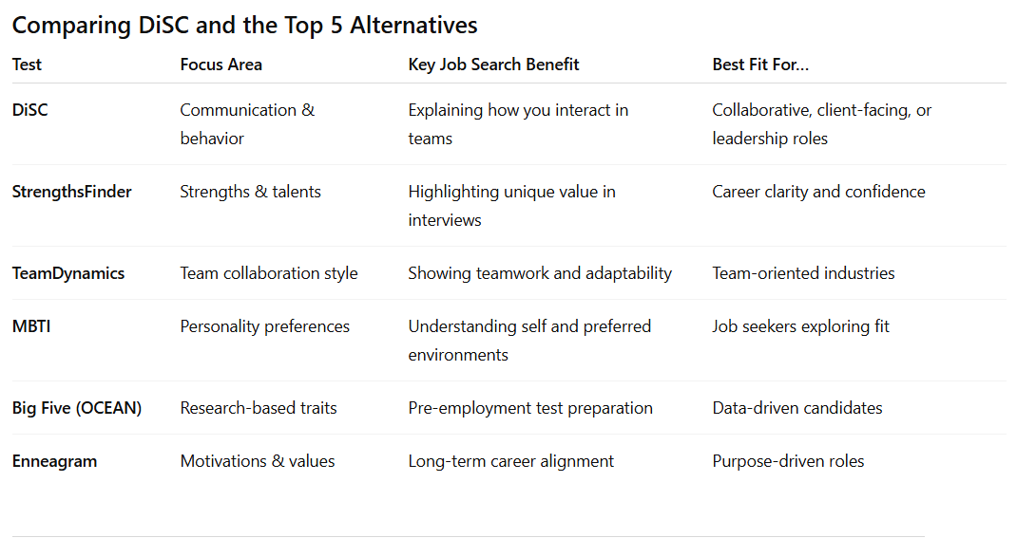

Frequently Asked Questions
1. Are personality tests required for job seekers?
No—but they can give you language to describe your strengths, preferences, and values, which is especially useful during interviews or networking conversations.
2. Which test is the most accurate?
The Big Five has the strongest scientific backing. However, the “best” test depends on what you need—confidence, self-awareness, or team fit.
3. Can I use test results on my resume or LinkedIn?
Yes, but use them strategically. Instead of saying “I’m an ENFJ,” translate the insight into workplace value: “I thrive in people-centered environments where collaboration drives results.”
4. Do employers actually use these tests?
Some do. Many companies use the Big Five or DiSC during recruitment. Even if not required, understanding your results can help you align your personal brand to the company culture.

Final Thoughts
Your Next Steps
- Choose your Assessment - Based on your current job search needs—confidence, team fit, career direction, or scientific preparation—select the assessment that aligns with your goals.
- Take Action - Complete your chosen assessment and thoroughly review your results. Take notes on key insights that resonate with your experience and career aspirations.
- Apply Insights - Integrate your assessment results into your resume, LinkedIn profile, and interview preparation. Practice translating personality insights into professional value statements.
- Track Results - Monitor how assessment-informed approaches improve your interview confidence, networking conversations, and overall job search effectiveness.
Finding the right job is not only about skills—it’s also about fit. Personality assessments, whether it’s StrengthsFinder, TeamDynamics, MBTI, the Big Five, or the Enneagram, give you tools to understand yourself and communicate more effectively with employers. While none of these tests should define your career path, they can illuminate how you work best, how you collaborate, and how you can thrive in your next role.
#CareerDevelopment #JobSearchTips #StrengthsFinder #CliftonStrengths #TeamDynamics #MBTI #BigFive #Enneagram #DiSC #CareerClarity #InterviewPreparation #WorkplaceSuccess #SelfAwareness #CareerAlignment #ProfessionalGrowth #JobSeekers #CareerCoaching #Teamwork #LeadershipDevelopment #HiringInsights

