# Dynamics 365 Certification Landscape: Two Sides of the House

**Published on 19 August 2025 at 19:10**

**By Kimberly Wiethoff**

Welcome to your comprehensive guide to Microsoft Dynamics 365 certifications. This presentation maps out the certification paths across both the Customer Engagement (CRM) and Finance & Operations (ERP) domains, helping you strategically plan your certification journey and career growth in the Dynamics 365 ecosystem.

Whether you’re just starting your journey with Microsoft Dynamics 365 or already working with CRM and ERP applications, understanding the certification paths can be a game-changer. Certifications not only validate your skills but also open doors to new career opportunities, helping you stand out in a competitive job market. In this blog, we’ll walk through the **entire Dynamics 365 certification landscape**—covering both **Customer Engagement (CRM)** and **Finance & Operations (ERP)**—so you can clearly see where each exam fits in and which path aligns with your career goals.

## 1. Customer Engagement (CRM)

This is the front-office side: Sales, Marketing, Service, and Field Service.

* **Fundamentals Exam** → **MB-910 (Dynamics 365 Fundamentals – CRM) -** This foundational exam validates your understanding of Customer Engagement applications, basic functionality, and use cases across Sales, Customer Service, Marketing, and Field Service. Ideal for: Business users, stakeholders, IT professionals new to Dynamics 365, Difficulty: Beginner
* **Role-Based Exams** → MB-210 (Sales), MB-220 (Marketing), MB-230 (Customer Service), MB-240 (Field Service)
  + MB-210: Dynamics 365 Sales Functional Consultant Associate
    - Key Skills Validated: Implementing sales processes, configuring product catalogs, setting up forecasts, enabling sales intelligence tools
      * Lead and opportunity management
      * Sales automation and forecasting
      * Product catalog configuration
      * Quote-to-order processes
      * Sales insights and analytics
  + MB-220: Dynamics 365 Marketing Functional Consultant Associate
    - Key Skills Validated: Configuring marketing settings, creating segments, building customer journeys, implementing event management
      * Customer journey orchestration
      * Marketing email creation
      * Lead management and scoring
      * Event management
      * Marketing analytics
  + **MB-230:** Dynamics 365 Customer Service Functional Consultant Associate
    - Key Skills Validated: Implementing case management, configuring SLAs, setting up knowledge articles, enabling service analytics
      * Case management
      * Knowledge base setup
      * Service-level agreements
      * Queue configuration
      * Customer service insights
  + **MB-240:** Dynamics 365 Field Service Functional Consultant Associate
    - Key Skills Validated: Configuring field service settings, implementing resource scheduling, managing inventory, setting up mobile solutions
      * Resource scheduling
      * Work order management
      * Inventory and purchasing
      * Mobile app configuration
      * Asset management

Each exam focuses on implementing, configuring, and customizing specific Customer Engagement applications

* **New Path** → Customer Experience Analyst Associate (launching September 2024)
  + This new certification will integrate customer experience analytics across the Customer Engagement applications, focusing on deriving insights from customer data.

## 2. Finance & Operations (ERP / Back Office)

This is the back-office side: Finance, Supply Chain, Commerce, HR, Manufacturing.

* **Fundamentals Exam** → **MB-920 (Dynamics 365 Fundamentals – Finance & Operations)**
  + Covers ERP concepts like finance, supply chain, HR, and commerce in Dynamics 365.

**Role-Based Exams (Associate Level)**:

* **MB-310 Finance Functional Consultant -** validates your ability to implement and configure Dynamics 365 Finance, focusing on core financial management processes and capabilities. This certification emphasizes practical implementation scenarios rather than theoretical knowledge. The MB-310 exam evaluates your ability to configure the Finance module and implement solutions that address complex financial requirements for organizations. Key focus areas include:
  + **General Ledger Configuration**, covering chart of accounts, fiscal calendars, dimensions, and financial reporting.
  + **Accounts Payable** includes vendor management, invoice processing, payment setup, and vendor collaboration.
  + **Accounts Receivable** involves customer setup, credit management, invoicing, collections, and customer payment processing.
  + **Cash and Bank Management** focuses on bank reconciliation, cash flow forecasting, and advanced bank reconciliation.
  + **Fixed Assets** covers asset acquisition, depreciation, disposal, and financial reporting. Finally,
  + **Budgeting** includes budget planning, control, register maintenance, and budget workflows.
* **MB-330 Supply Chain Management** validates your ability to implement and configure Dynamics 365 Supply Chain Management, focusing on end-to-end supply chain processes from procurement to manufacturing and distribution. This certification is particularly valuable for consultants working with manufacturing, distribution, or retail organizations with complex supply chain requirements. The MB-330 exam evaluates your ability to optimize supply chain processes, improve operational efficiency, and implement solutions that address complex supply chain challenges. It requires an understanding of the interrelationships between different supply chain components. Key focus areas include:
  + **Inventory Management**, which covers item setup, inventory transactions, inventory valuation, and inventory dimensions.
  + **Warehouse Management** addresses warehouse configurations, location directives, mobile device setup, and wave processing.
  + **Manufacturing Processes** focuses on production control, discrete manufacturing, lean manufacturing, and process manufacturing.
  + **Master Planning** involves demand forecasting, safety stock, planning optimization, and material requirements planning.
  + **Procurement** includes purchase requisitions, RFQs, purchase orders, vendor collaboration, and procurement catalogs.
* The **F&O Certification: MB-330 Supply Chain Management** validates your ability to implement and configure Dynamics 365 Supply Chain Management, focusing on end-to-end supply chain processes from procurement to manufacturing and distribution. This certification is particularly valuable for consultants working with manufacturing, distribution, or retail organizations with complex supply chain requirements. The MB-330 exam evaluates your ability to optimize supply chain processes, improve operational efficiency, and implement solutions that address complex supply chain challenges. It requires understanding the interrelationships between different supply chain components. **Key Focus Areas:**
  + **Inventory Management**: Item setup, inventory transactions, inventory valuation, inventory dimensions
  + **Warehouse Management**: Warehouse configurations, location directives, mobile device setup, wave processing
  + **Manufacturing Processes**: Production control, discrete manufacturing, lean manufacturing, process manufacturing
  + **Master Planning**: Demand forecasting, safety stock, planning optimization, material requirements planning
  + **Procurement**: Purchase requisitions, RFQs, purchase orders, vendor collaboration, procurement catalogs
* **Developer Path**:
  + **MB-500: Dynamics 365 Finance and Operations Apps Developer Associate** → Extending, integrating, and customizing F&O apps. The MB-500 certification validates your ability to extend and customize Dynamics 365 Finance and Operations applications using development tools and programming techniques specific to the platform. Unlike the functional consultant certifications, which focus on configuration, this exam evaluates your ability to write code, create customizations, and integrate with other systems. Key Technical Areas
    - X++ Programming: Develop using the proprietary X++ language, including classes, methods, and data types
    - Development Environment: Work with Visual Studio and other development tools in the Dynamics ecosystem
    - Data Entities: Create and extend data entities for data management and integration
    - Forms and Reports: Design and modify user interfaces and reporting solutions
    - Extensions: Develop using the extensions framework rather than overlayering
    - Extensions: Develop using the extensions framework rather than overlayering
    - Integration: Implement integrations using various technologies (OData, data entities, event frameworks)
    - Performance Optimization: Optimize code and queries for performance
    - Application Lifecycle Management: Manage code, deployments, and environments
* **Legacy Change (Important!)**:
  + Previously, MB-300 (Core Finance & Operations) + a specialization exam (like MB-310 or MB-330) were both required.
  + Since **Feb 29, 2024**, MB-300 was **retired**. Now you only need the **specialization exam** (MB-310, MB-330, etc.).

**3. How CRM and F&O Fit Together**

* **CRM (Customer Engagement)** = Front office → managing customers, sales, service, and marketing.
* **F&O (ERP / Back Office)** = Back office → handling finance, supply chain, commerce, HR.
* Together, they form the **full Dynamics 365 ecosystem**, and many real-world projects involve integrating both sides.
* Integration Points
  + **Customer Master Data:** Shared customer records between CRM and F&O
  + **Quote-to-Cash:** Sales opportunities in CRM convert to orders in F&O
  + **Product Catalog:** Products managed in F&O surfaced in CRM for sales
  + **Inventory Visibility:** Real-time inventory from F&O available in CRM
  + **Service Management**: Service cases linked to financial transactions
  + **Financial Reporting:** Sales performance from CRM combined with financial data from F&O
* Implementation considerations - Most enterprise implementations involve both sides of the Dynamics 365 house, requiring professionals to understand how the systems interact:
  + **Data Synchronization:** Defining master data strategy across systems
  + **Process Handoffs:** Designing seamless transitions between front and back office
  + **Integration Technologies:** Using Power Platform, dual-write, or custom integrations
  + **User Experience:** Creating a unified experience across applications
  + **Security Model:** Managing permissions across the ecosystem

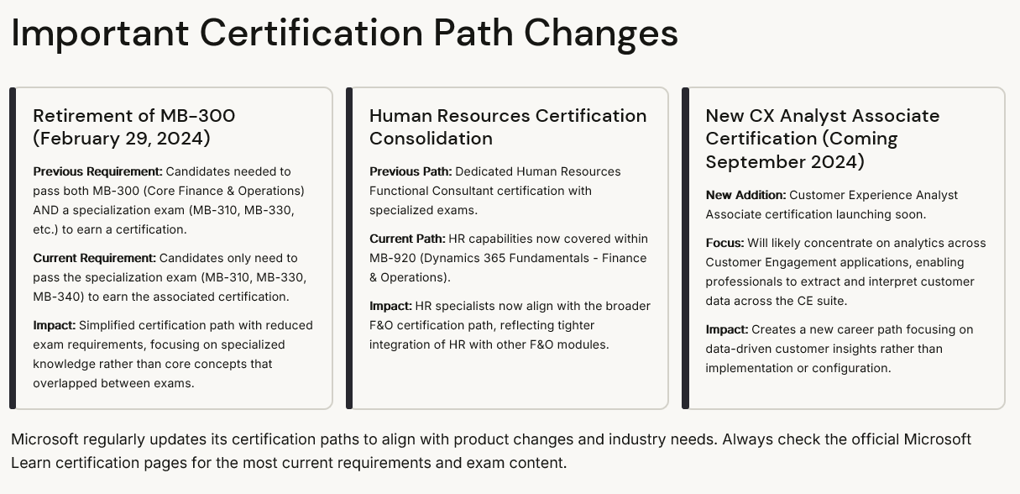

## ✅ So in short:

1. Assess your current role and career goals
   * Customer facing = Customer Engagement (CRM)
   * Financial or Operational = F&O (ERP)
   * Technical/developer = Developer Certifications (Power Platform or MB-500)
2. Start with Fundamentals
3. Specialize Based on your focus area
   * If you’re on the **CRM track**, start with MB-910 → then Sales/Service/Marketing/Field Service.
   * If you’re on the **ERP / F&O track**, start with MB-920 → then Finance (MB-310), Supply Chain (MB-330), Commerce (MB-340), or Developer (MB-500).
4. Expand your expertise across domains
   * Consider certifications from both sides of the house to become a more versatile Dynamics 365 professional capable of working on integrated implementations.
   * The most valuable consultants understand how both CRM and F&O work together in real-world scenarios.

Remember that certifications validate your knowledge, but real-world experience remains equally important. Combine certification preparation with hands-on practice in demonstration environments to maximize both your exam success and practical skills.

#MicrosoftDynamics365 #Dynamics365 #MicrosoftCertification #ERP #CRM #FinanceAndOperations #Dynamics365CRM #MicrosoftLearn #ERPConsulting #CRMConsulting #ProjectManagement #CareerGrowth