Power Platform Modernization: A 10-Step AI-Assisted Playbook
By Kimberly Wiethoff, MBA, PMP, PMI-ACP
A legacy application often carries years of business knowledge inside its screens, approval rules, integrations, and workarounds. Replacing it requires understanding how people use it, including the exceptions that rarely appear in the documentation.
That is where modernization projects can lose their footing. A team demonstrates a promising prototype, starts rebuilding screens, and discovers later that an undocumented approval rule or missing historical record affects a critical business process.

10 Step AI Assisted Playbook
My two companion presentations provide a framework for managing that transition. Part 1, Power Platform Modernization: A 10-Step AI-Assisted Playbook, connects each delivery phase to concrete deliverables, measurable acceptance criteria, and practical opportunities for AI assistance. Part 2, Power Platform Modernization: Questions Leaders Should Ask & the Role of the Program Manager, explores the leadership decisions, program oversight, and operational responsibilities needed to guide modernization from planning through sustained support.
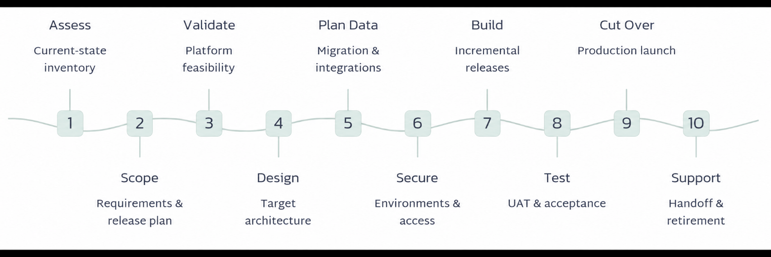
Together, they show how AI can support delivery while named business and technical owners remain accountable for validation and approval. For project managers and PMO leaders, the central question is: What evidence shows that we are ready to move to the next phase?
Step/Evidence to Move | What Needs to be Done | How AI can Help

Assess the Current Application
Evidence to move forward: Business and technical owners validate the current-state assessment, including the dependencies and rules that affect the proposed migration. | Document the application as it operates today. Inventory its screens, workflows, business rules, reports, integrations, data sources, and user roles. Identify who owns each area and which other systems depend on it.  Talk with the people who use the application every day. A spreadsheet maintained outside the system may reveal an unmet reporting need. A manual approval workaround may explain why the documented process no longer matches reality. | AI can summarize existing documentation, suggest process maps, and extract candidate business rules from legacy code. It can also generate questions about gaps. Treat these outputs as drafts for knowledgeable users and technical owners to review.

2. Define Scope and Success Measures
Evidence to move forward: Every in-scope requirement has an owner, priority, and testable acceptance criterion. Stakeholders approve the release scope and measurable outcomes. | Decide which capabilities the organization will retain, improve, or retire. Establish a manageable first release and document its exclusions so stakeholders understand what to expect.  Define success before development starts. “Improve efficiency” needs a baseline and a target. For example, a team might aim to reduce the time employees spend submitting a request from its measured current level to an agreed target. That gives the project something meaningful to evaluate after launch. | AI can turn stakeholder notes into user stories and identify conflicting or ambiguous requirements. Product owners must confirm that those stories reflect the business need.

3. Confirm Power Apps Suitability
Evidence to move forward: The team demonstrates that critical scenarios are feasible and documents any constraints, costs, and accepted risks. | Validate the platform against the application’s actual requirements before committing to the full build.  Consider expected data volumes, concurrent users, response times, integration dependencies, and any offline needs. Review licensing assumptions and connector policies using current Microsoft guidance.  A targeted proof of concept should exercise the highest-risk scenarios with representative data. A successful demonstration using a handful of records tells the team little about a workload involving substantially larger volumes. | AI can help organize a feasibility checklist and compare options. Architects and platform specialists should verify the assumptions behind the recommendation.

4. Select the Application Architecture
Evidence to move forward: The solution architect and technical lead approve a design that covers required user journeys, access needs, and supportability. | Choose the application approach around the required user journeys. The presentation identifies canvas apps, model-driven apps, or a combination, with Power Pages considered for external users and Power Automate for supporting workflows.  Document the data platform, integrations, and automation approach. Include how the solution handles errors and how support teams will investigate failures.  For example, an approval workflow needs an agreed response when its notification fails. The design should make the failure visible and explain who can recover the process without duplicating the approval. | AI can draft architecture comparisons and propose initial data relationships. Technical owners should review these suggestions against the approved requirements.

5. Plan the Data and Integrations
Evidence to move forward: Trial migrations meet approved reconciliation criteria, and integrations recover without unexplained data loss or duplication. | Data migration deserves its own workstream. Map fields, relationships, attachments, and required historical records. Define how legacy identifiers connect to the new data model.  Agree on transformation and reconciliation rules before moving production records. Matching record counts is useful, but it does not prove that relationships, values, or attachments survived correctly. | AI can suggest mappings, flag potential quality issues, and draft reconciliation queries. Data owners must validate the results using representative records, including exceptions.  Integration testing should cover normal processing, failures, and recovery. If a transaction retries after a timeout, the team needs evidence that it does not create a duplicate.

6. Establish Environments and Security
Evidence to move forward: The team verifies permissions, approves connector policies, and completes a deployment rehearsal using the correct environment configuration. | Prepare development, test, and production environments before build work expands. Establish security roles, connector policies, and deployment controls.  Permission testing should demonstrate both sides of access: users can perform authorized actions, and they cannot access restricted information or functions. | AI can draft access matrices and configuration checklists. Security owners should review them, and teams should use synthetic or appropriately anonymized information when working with AI tools. Production credentials must remain protected.

7. Build the Application Incrementally
Evidence to move forward: Implemented requirements trace to demonstrated functionality that meets its acceptance criteria. | Deliver working functionality in short increments and review it with business representatives. Early demonstrations help users identify misunderstandings while changes remain manageable. | AI can assist with Power Fx formulas, workflow drafts, and explanations of development errors. Developers must understand and test suggested logic before incorporating it.  Keep each increment connected to approved requirements. A polished screen provides limited evidence if its calculations or approval rules behave differently from what the business accepted.

8. Test and Obtain Business Acceptance
Evidence to move forward: Critical scenarios pass, agreed targets are met, and business representatives approve release readiness based on documented results. | Test complete business journeys alongside permissions, integration recovery, performance, and accessibility. Business representatives should conduct user acceptance testing using realistic tasks and exceptions. | AI can generate candidate test cases and synthetic data. Review the expected results independently: a test suite that repeats the same mistaken assumption as the requirements can create false confidence.  Record actual execution evidence and resolve critical defects before release. Any authorized exception needs a named approver and documented rationale.

9. Prepare and Execute Cutover
Evidence to move forward: Rehearsal results support the plan, production checks pass, and decisionmakers have the evidence needed to authorize launch or rollback. | Create a cutover plan with named owners, timing, dependencies, and rollback triggers. Rehearse the migration and confirm support coverage before releasing the application to users.  The final transition should include data reconciliation and production smoke tests. Role-based training should help employees complete their work and recognize when they need assistance. | AI can draft training materials and summarize rehearsal findings. The team must verify that the materials match the actual release and that the plan reflects demonstrated migration timing.

10. Transition to Support and Retire the Legacy System
Evidence of completion: Support operates independently, the application meets agreed stability targets, and the organization approves legacy retirement with archival evidence. | Assign a named support owner and transfer the runbooks, access, monitoring, and escalation responsibilities. Agree on a stability period and monitor adoption as well as incidents.  A signed handoff establishes responsibility. A support team independently resolving representative incidents demonstrates that the transition works. | AI can help draft FAQs and summarize recurring issues into improvement opportunities. Support owners should review recommendations and decide which changes enter the backlog.  Retire the legacy application only after the organization satisfies its archival and acceptance conditions. Confirm that required records remain retrievable before removing access.

Use Given / When / Then acceptance criteria to make expected behavior explicit:
Given an authorized approver has a request awaiting review, when they approve it, then the status changes to Approved, the application records the approver and timestamp, and the requester receives a notification within the agreed time limit.
Replace placeholders with approved values before testing. Include rejection, unauthorized

Questions Leaders Should Ask Before Modernization Begins
Before approving a Power Platform modernization initiative, leaders should establish a shared understanding of the business problem, investment, and operating responsibilities. These questions help expose assumptions that could become costly during delivery.
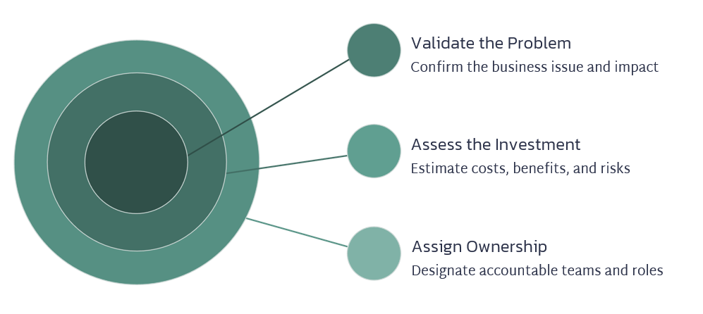

What business problem are we solving?
Identify the specific limitation driving modernization. Is the existing application slowing work, creating data errors, increasing support costs, or preventing needed changes? Define the outcome that would justify the investment.

What should we improve or retire before rebuilding?
Review whether existing workflows and approvals still serve a business purpose. Recreating unnecessary steps can carry years of inefficiency into the new application.

What evidence supports Power Platform as the right choice?
Ask the team to demonstrate the highest-risk requirements using representative workloads. Confirm that platform suitability, integrations, and licensing assumptions have received technical review.

Do we understand the full cost of ownership?
Include migration, licensing, training, support, and ongoing enhancements in the financial assessment. Identify who will fund the application after project funding ends.

Who owns the process, data, and release decisions?
Name the people authorized to approve requirements, resolve data-quality issues, accept risks, and authorize launch. Clarify how the team will escalate disagreements.

Where will AI help, and who will validate its outputs?
Identify approved uses of AI and the information teams may share with it. Assign qualified reviewers for generated requirements, formulas, mappings, and test cases.

What must be true before we launch and retire the legacy system?
Agree on measurable release criteria, rollback triggers, and archival requirements. Establish how the support team will demonstrate that it can operate independently.
These answers should shape the business case and delivery plan. Revisit them when scope, costs, or technical findings materially change.

The Role of the Program Manager
The program manager connects the modernization effort to business outcomes and coordinates the work across business, technology, security, and operations. Their responsibility includes making sure decisions happen at the right time and that evidence supports each transition.
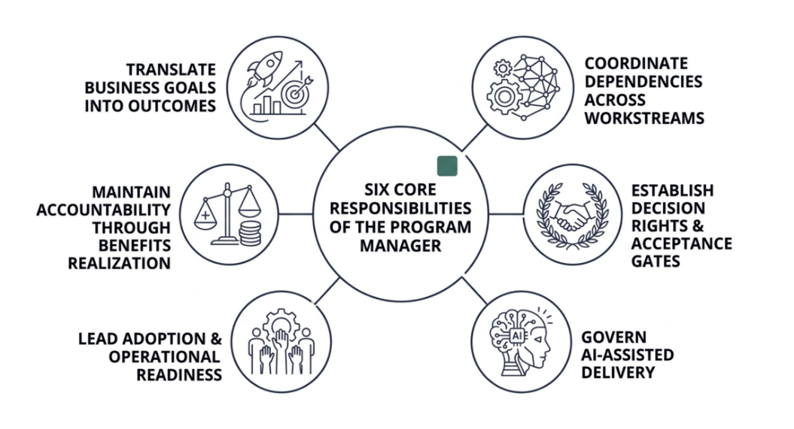

Translate Business Goals Into Measurable Outcomes
Work with the sponsor and process owners to establish baselines and targets. Connect the delivery backlog to outcomes such as shorter processing times, fewer manual corrections, or improved access to reliable information.
Continue measuring after launch so leaders can assess whether the application delivers the expected benefit.

Coordinate Dependencies Across Workstreams
Application development depends on data readiness, integration availability, environment setup, security decisions, and user participation.
Maintain a clear view of these dependencies, with an owner and required date for each. Surface blocked decisions early and explain their effect on the release plan.

Establish Decision Rights and Acceptance Gates
Define who approves scope, architecture, data reconciliation, business acceptance, and production launch. Ensure each phase has an agreed deliverable and acceptance criteria.
Bring unresolved issues to the appropriate decision-maker with options and consequences. Record approved exceptions and the responsibilities attached to them.

Govern AI-Assisted Delivery
Ensure AI use follows the organization’s approved data-handling rules and review standards. Each AI-assisted deliverable should have a named owner responsible for its accuracy and acceptance.
Account for review effort in the delivery plan. Faster drafting only improves delivery when the team has enough capacity to validate the output.

Lead Adoption and Operational Readiness
Plan user involvement, training, and support preparation alongside development. Use feedback from demonstrations and testing to identify adoption barriers before launch.
Verify that support teams have the access, documentation, and practical experience needed to resolve incidents independently.

Maintain Accountability Through Benefits Realization
Track stability, adoption, and business outcomes through hypercare and the agreed transition period. Assign ongoing ownership for unresolved issues and future improvements.
The program manager’s work is complete when the organization has accepted a sustainable capability, demonstrated operational readiness, and established ownership for measuring its continuing value.

Keep AI Assistance Reviewable
The strongest starting opportunities in this playbook are documentation analysis, requirements drafting, development assistance, and test-case generation. Each produces an output that a qualified person can inspect and validate.
Apply the same quality standards to AI-assisted work as to other deliverables. Review generated content against source material, test generated logic, and validate proposed data mappings through reconciliation. Named owners should approve release decisions, regardless of how the supporting work was prepared.
For the PMO, a useful checkpoint is simple: What did AI help produce, who reviewed it, and what evidence supports its acceptance?
That question keeps modernization focused on a working business capability. The project succeeds when employees can complete their work, the organization can trust its data, and support teams can sustain the application after the project team leaves.
Use the companion presentation to guide planning discussions and phase reviews. Set each acceptance threshold around your application’s business needs and risk before delivery begins.

About the Author
Kimberly Wiethoff, MBA, PMP, PMI-ACP is an AI Transformation Program Leader specializing in enterprise digital transformation, AI-enabled delivery, PMO leadership, AI governance, Agile program execution, cloud transformation, and complex portfolio delivery.
Through Managing Projects the Agile Way, she shares practical strategies for modernizing project and program delivery, strengthening PMO leadership, and preparing organizations and leaders for the future of AI-enabled program management.
#PowerPlatform #PowerApps #PowerAutomate #ApplicationModernization #DigitalTransformation #AI #AIGovernance #ProgramManagement #ProjectManagement #PMO #ChangeManagement #BusinessTransformation #AgileDelivery #ManagingProjectsTheAgileWay

