SAFe vs Agile Project Management: What’s the Difference?
Published on 7 May 2025 at 10:40
Author: Kimberly Wiethoff
In the world of project delivery, Agile has become a buzzword synonymous with speed, collaboration, and adaptability. But as organizations scale Agile practices beyond small teams, frameworks like SAFe (Scaled Agile Framework) have emerged to bring structure to enterprise-level agility.
For project managers, the question often arises: How is SAFe different from traditional Agile project management? While both aim to improve delivery through iterative development and customer collaboration, they diverge in scale, structure, and roles.
Let’s break it down.

1. Scale of Implementation
- Agile Project Management typically applies to single teams (7±2 members) using Scrum or Kanban to manage their own backlog, sprints, and ceremonies. It's ideal for startups, small teams, or isolated initiatives.
- SAFe is designed for large enterprises with multiple Agile teams working on a shared product or solution. It introduces layers like Agile Release Trains (ARTs) and Value Streams to coordinate across teams.
📌 Key difference: SAFe enables agility at scale, while traditional Agile is optimized for small, autonomous teams.

2. Framework Structure
- Agile Project Management is flexible, allowing teams to customize their workflows and ceremonies. It follows the Agile Manifesto principles but doesn’t dictate how to scale or align with enterprise strategy.
- SAFe is a prescriptive framework with defined roles, events (e.g., PI Planning), and artifacts that align development with business strategy through Lean Portfolio Management.
📌 Key difference: SAFe provides a structured blueprint for scaling Agile across the enterprise; Agile PM is more team-centric and lightweight.

3. Roles and Responsibilities
- In Agile PM, roles like Scrum Master, Product Owner, and the Agile Team are central. The Project Manager role may still exist in hybrid environments but is not formalized in pure Agile.
- In SAFe, new roles emerge, including:
  - Release Train Engineer (RTE) – the servant leader of the Agile Release Train
  - System Architect, Business Owners, and Solution Train Engineer (at higher levels)
  - Lean Portfolio Managers overseeing strategic investment and budgeting
📌 Key difference: SAFe distributes responsibilities across multiple clearly defined roles to manage complexity at scale.

4. Planning Cadence
- Agile teams plan in short sprints (usually 2 weeks), review progress during retrospectives, and continuously adjust.
- SAFe introduces **Program Increments (PIs)**—larger planning cycles (typically 8–12 weeks) involving multiple teams. PI Planning aligns the enterprise around a shared mission and roadmap.
📌 Key difference: SAFe uses multi-team synchronized planning; Agile PM focuses on individual team sprint planning.

5. Governance and Strategy Alignment
- Agile project management often lacks formal governance structures and relies on team autonomy.
- SAFe embeds Lean Portfolio Management, budget guardrails, and Epic Owners to align execution with strategic objectives and ensure governance.
📌 Key difference: SAFe integrates enterprise governance and funding models into Agile delivery.

So, Which One is Right for You?
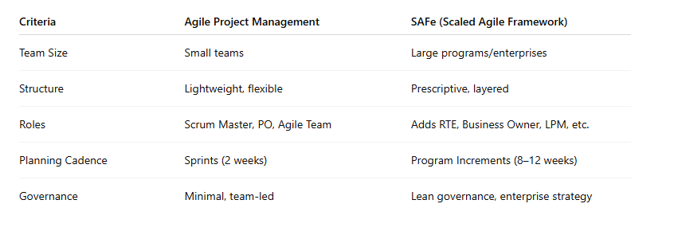

Final Thoughts
Both SAFe and Agile project management share a common DNA rooted in the Agile Manifesto, but their applications diverge based on scale, complexity, and organizational needs. Agile PM is perfect for small, nimble teams looking for speed and autonomy. SAFe is ideal for large organizations seeking alignment, coordination, and governance across dozens of Agile teams.
As a project manager, understanding these differences will empower you to adapt your leadership style, choose the right framework for your context, and drive Agile transformation with confidence.

#SAFe #AgileProjectManagement #ScaledAgile #SAFeFramework #ProjectManagerTips #AgileVsSAFe #ProgramIncrementPlanning #LeanPortfolioManagement #AgileAtScale #ManagingProjectsTheAgileWay

