PgMP® vs. PfMP®: Which PMI Certification Is Right for Your Career Path?
Published on 23 May 2025 at 09:59
By Kimberly Wiethoff
As organizations evolve and strategies grow increasingly complex, experienced project professionals often seek to move beyond project execution into roles that drive broader business impact. That’s where two of PMI’s most advanced certifications come into play: Program Management Professional (PgMP®) and Portfolio Management Professional (PfMP®).
While both certifications validate leadership at a strategic level, they serve distinct purposes and audiences. Understanding the difference is key to selecting the certification that best aligns with your career goals.

🎯 What Do PgMP® and PfMP® Certify?
- PgMP® is ideal for professionals managing multiple related projects—called programs—that are coordinated to achieve strategic business outcomes. It’s about execution with alignment.
- PfMP® targets executives and senior leaders responsible for managing portfolios—collections of programs, projects, and operations—to ensure strategic investments deliver maximum business value. This is strategy at the enterprise level.

📚 Exam Focus: Tactical vs. Strategic Leadership
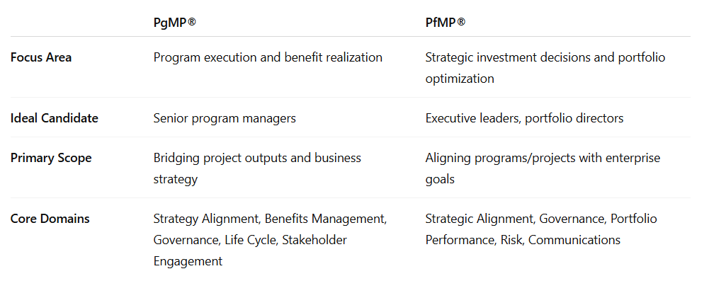

Both exams consist of 170 multiple-choice questions over 4 hours, but PfMP® emphasizes enterprise-level decision-making and risk-return tradeoffs, while PgMP® focuses on program integration and benefits realization.

✅ Eligibility Requirements
Each certification requires a combination of education and deep experience in either program or portfolio management:
PgMP®
- With a 4-year degree: 4 years of project management + 4 years of program management
- With a secondary degree: 4 years of project management + 7 years of program management
PfMP®
- With a 4-year degree: 8 years of business experience + 4 years of portfolio management
- With a secondary degree: 8 years of business experience + 7 years of portfolio management
Both also require a panel review prior to sitting for the exam to validate experience.

💲 Certification Cost


🔁 Renewal Requirements
To maintain either certification, you must earn 60 PDUs (Professional Development Units) every three years—focused on program management (PgMP®) or portfolio management (PfMP®).

🧭 Which One Should You Choose?
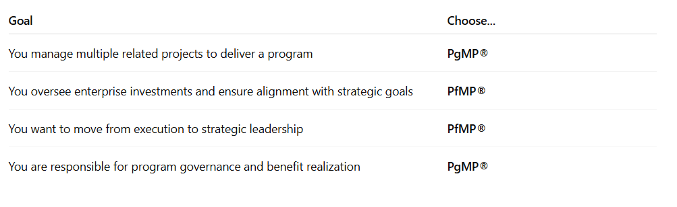

Final Thoughts
Both PgMP® and PfMP® are prestigious credentials that demonstrate your ability to lead beyond the project level. If your career is shifting toward strategic decision-making and investment oversight, PfMP® may be the better fit. If your focus is still on execution through coordinated programs, then PgMP® is the logical next step.
Either way, earning one of these certifications will distinguish you as a leader who can drive organizational success—not just complete projects.

#PfMP #PgMP #PMICertification #PortfolioManagement #ProgramManagement #StrategicLeadership #ProjectManagement #PMI #CareerGrowth #AgileLeadership #ExecutivePresence #PMO #ManagingProjectsTheAgileWay

