Project Director Candidate Scorecard
Here’s a clean and structured Candidate Scorecard you can use when interviewing candidates for a Project Director position. You can easily adapt this into a digital form, Excel sheet, or printed handout.
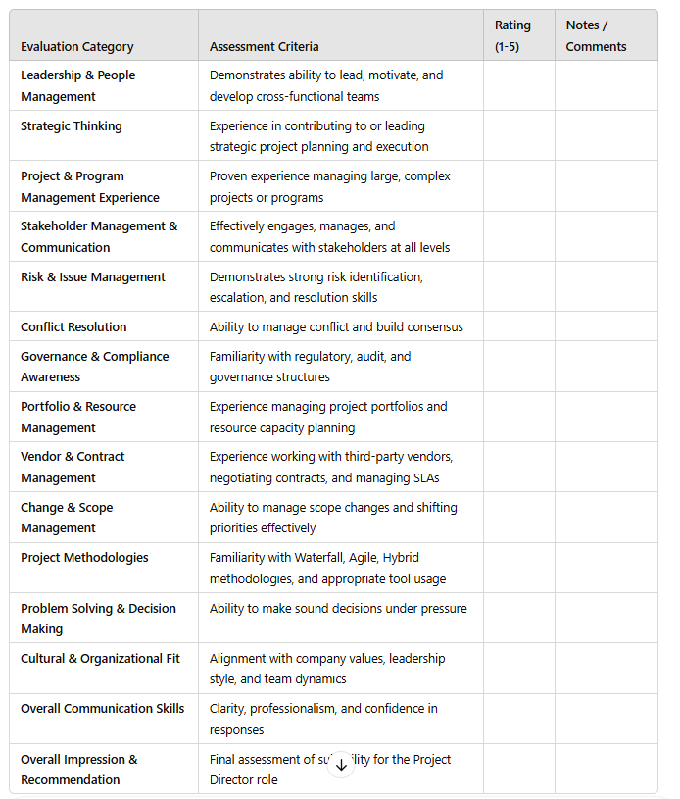

⭐ Rating Scale
1 = Poor / Major Gaps
2 = Below Average / Limited Experience
3 = Meets Expectations
4 = Strong / Above Average
5 = Outstanding / Exceeds Expectations

