PMP® vs. PMI-ACP®: Which Project Management Certification Is Right for You?
Published on 4 June 2025 at 11:55
By Kimberly Wiethoff
In today's fast-evolving business landscape, project managers are expected to master not only traditional project management but also Agile methodologies. The Project Management Institute (PMI) offers two globally respected certifications that cater to these distinct—but often complementary—approaches: the PMP® (Project Management Professional) and the PMI-ACP® (Agile Certified Practitioner).
But how do these certifications differ? And which one should you pursue? In this post, we’ll break down the key differences, similarities, and when to choose one (or both).

🎓 What Is the PMP®?
The PMP® certification is the gold standard for project managers across industries. It validates your ability to manage projects using predictive (waterfall), Agile, and hybrid approaches—making it a versatile and comprehensive credential.

🧩 PMP® Focus Areas:
- Project scope, schedule, cost, quality, and risk management
- Stakeholder and communications management
- Integration of project phases across lifecycle
- Predictive, Agile, and hybrid delivery models
- Leadership and team management skills

📋 Prerequisites:
- 4-year degree + 36 months of project experience, or
- High school diploma + 60 months of experience
- 35 hours of formal project management education or CAPM®

🚀 What Is the PMI-ACP®?
The PMI-ACP® certification focuses exclusively on Agile practices, drawing from frameworks such as Scrum, Kanban, XP, Lean, and more. It’s ideal for professionals working in Agile teams or those transitioning into Agile project environments.

🧩 PMI-ACP® Focus Areas:
- Agile mindset and principles
- Value-driven delivery
- Stakeholder engagement
- Team performance and continuous improvement
- Adaptive planning and Agile estimation
- Risk management in Agile settings

📋 Prerequisites:
- Secondary degree (high school or equivalent)
- 12 months of general project experience in the last 5 years
- 8 months of Agile project experience in the last 3 years
- 21 contact hours of Agile training

⚖️ PMP® vs. PMI-ACP®: Key Differences
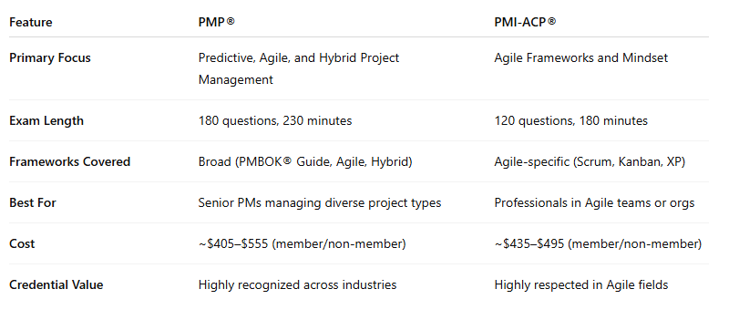

🧠 When Should You Choose PMP®?
- You're leading cross-functional, complex projects
- You want to validate both Agile and traditional project skills
- You’re pursuing a leadership role in program or portfolio management
- You need a globally recognized credential to advance your PM career

🤹‍♀️ When Should You Choose PMI-ACP®?
- You’re part of an Agile or Scrum team
- You work in tech, product development, or digital transformation
- You want to prove your expertise in Agile frameworks
- You’re aiming to become an Agile Coach, Scrum Master, or Agile PM

💡 Why Not Both?
In many organizations, PMP® and PMI-ACP® complement each other. PMP provides strategic leadership, stakeholder management, and project control expertise, while PMI-ACP demonstrates agility, team facilitation, and value-driven delivery.
Having both certifications signals that you’re adaptable, well-rounded, and prepared to lead in any project environment.

📣 Final Thoughts
The right certification depends on your current role, career aspirations, and the environments you work in. If you're navigating waterfall-heavy projects, PMP is a must. If your world revolves around sprints, backlogs, and user stories, PMI-ACP will feel like home.
Whichever path you choose, both certifications equip you with the tools to drive success in a world where change is constant, and agility is key.

🔗 Related Reads
- PMI – PMP Certification Overview
- PMI – PMI-ACP Certification Overview
- How to Study for the PMP in 2024
- Top 10 Agile Metrics Every Scrum Master Should Know

If you're exploring which certification is right for your career path, whether it's mastering traditional project management or diving deeper into Agile frameworks, this breakdown of PMP and PMI-ACP is for you. Join the conversation and share your journey using hashtags like #PMP #PMIACP #ProjectManagement #AgileProjectManagement #PMICertification #ScrumMaster #AgileMindset #HybridProjectManagement #PMPCertified #AgileLeadership #ContinuousLearning #CareerDevelopment #TechCareers and stay connected with professionals navigating similar paths.

