The Value-Generating PMO Flywheel: How Momentum Builds Sustainable Value
Published on 13 October 2025 at 15:40
By Kimberly Wiethoff, MBA, PMP, PMI-ACP
In today’s fast-changing business landscape, organizations can no longer afford PMOs that only manage templates, enforce compliance, or report status.
To stay relevant, the modern PMO must continuously generate measurable value — not through one-off initiatives, but through an evolving cycle of listening, learning, delivering, and improving. That’s the philosophy behind the Value-Generating PMO Flywheel, a framework introduced by Americo Pinto and the PMO Global Alliance as part of the PMO Value Ring methodology.
It redefines how PMOs operate: instead of functioning as a static department, the PMO becomes a living system of value creation, building momentum with every cycle.

🧭 What Is the PMO Flywheel?

10 Step Flywheel
Think of a flywheel in engineering terms: once it starts spinning, it stores energy and gains speed with each rotation, requiring less effort to keep it moving.
The Value-Generating PMO Flywheel works the same way. Each phase (See Table Below) — from stakeholder engagement to value delivery — fuels the next, creating self-reinforcing momentum that strengthens trust, alignment, and results.
A PMO that embraces this model doesn’t just complete projects; it earns credibility, drives change, and sustains long-term organizational health.

5 Stage - PMO Customer Experience Cycle
A five-stage process (exploration, design, deployment, enhancement, and realization) that ensures PMOs are delivering value in a way that resonates with their stakeholders. Each step in the PMO Flyweel corresponds with a stage in the PMO Customer Experience Cycle.
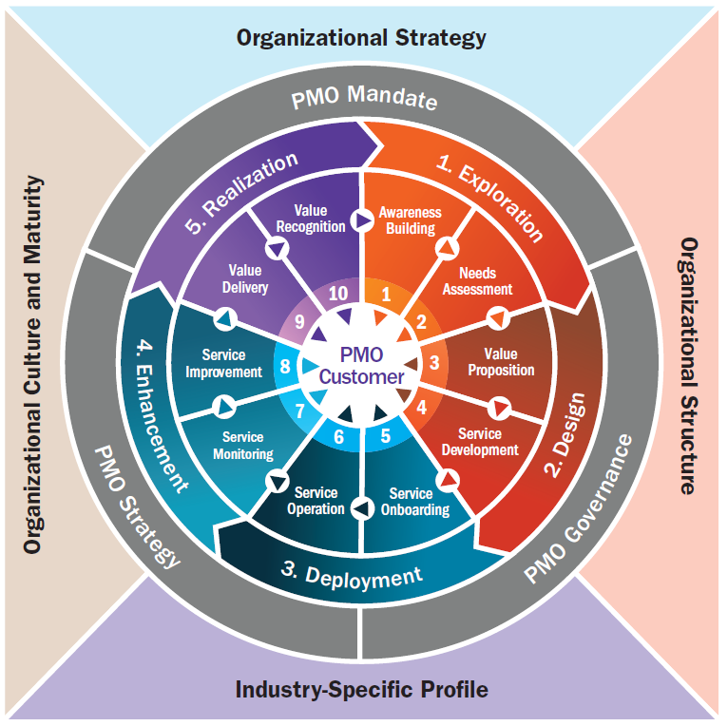

Three Pillars of PMO
The three pillars of a PMO—Mandate, Strategy, and Governance—form the structural foundation that defines how a PMO operates, delivers value, and maintains alignment with organizational goals.

PMO Mandate
The PMO Mandate defines the “why” of the PMO—its purpose, justification, and value proposition within the organization. It clarifies the PMO’s existence, objectives, and scope of influence (enterprise, departmental, or project-specific) and ensures alignment with strategic objectives. The mandate is formalized in the PMO charter, which includes the PMO’s vision, mission, coverage scope, stakeholders, roadmap, and success criteria.

PMO Strategy
The PMO Strategy defines the “what” and “how.” It outlines the long-term plan for how the PMO will evolve to continuously deliver value, identifying specific initiatives, priorities, and improvements needed to enhance performance and impact over time. The strategy ensures that PMO actions are purposeful, measurable, and tied to enterprise outcomes.

PMO Governance
The PMO Governance pillar represents the “who” and “when.” It establishes decision-making processes, roles, responsibilities, reporting lines, and accountability mechanisms that regulate how the PMO operates. Governance ensures consistency, transparency, and effectiveness in how the PMO manages portfolios, programs, and projects, maintaining alignment with organizational policies and standards.
Together, these three pillars give the PMO structure, direction, and authority—linking purpose (mandate), execution (strategy), and accountability (governance) into an integrated, value-driven framework.

⚙️ The 10 Steps of the Value-Generating PMO Flywheel
Step | Description | Purpose
1. Awareness Building | Communicate the PMO’s mission, role, and value proposition to the organization. | Establish visibility, transparency, and trust with stakeholders.
2. Needs Assessment | Listen carefully to business leaders, understand pain points, and uncover real needs behind their requests. | Diagnose before prescribing — the PMO acts like a physician, not a service catalog.
3. Value Proposition | Translate stakeholders needs into a tailored value offer. Define what success will look like and how it will be measured. | Ensure PMO services are outcome-oriented and customer-focused.
4. Service Development | Design or adapt PMO services, processes, and tools to deliver the promised value. | Build the “treatment plan” based on the diagnosis.
5. Service Onboarding | Manage adoption through change management, stakeholder alignment, and pilot runs. | Ensure the organization is ready to receive and use the service effectively.
6. Service Operation | Deliver PMO services consistently — project governance, portfolio visibility, resource management, etc. | Keep the PMO engine running with quality and discipline.
7. Service Monitoring | Track KPIs, customer satisfaction, and performance indicators. Gather data on service utilization and impact. | Measure what matters — evidence of value, not activity.
8. Service Improvement | Analyze feedback, identify gaps, and innovate. Adjust services to remain relevant and efficient. | Continuous improvement keeps the flywheel spinning.
9. Value Delivery | Demonstrate that the PMO’s services produce measurable outcomes — faster delivery, better ROI, reduced risk. | Convert PMO activity into visible business impact.
10. Value Recognition | Share results, success stories, and insights with leadership and teams. | Reinforce the PMO’s reputation and earn trust to begin the next cycle.

💡 Why the Flywheel Matters
Traditional PMOs often stall because they operate linearly — define processes, enforce compliance, report metrics, and repeat.
The flywheel approach is different. It’s dynamic, cyclical, and customer-centric.
Here’s why it works:
- It builds trust over time.
The PMO doesn’t demand authority — it earns it through demonstrated value, communication, and reliability.
- It replaces static maturity with continuous momentum.
Instead of “reaching” a final maturity level, the PMO keeps evolving, learning from each cycle.
- It connects purpose to outcomes.
Every activity in the flywheel links back to stakeholder needs and measurable business results.
- It reinforces organizational agility.
As priorities shift, the PMO adapts its services and keeps spinning — rather than restarting from scratch.

🩹 The PMO as a Physician — A Flywheel in Action
Just as patients aren’t expected to diagnose themselves or choose their own treatments, PMO customers shouldn’t have to pick services from a predefined list.
They may describe symptoms — missed deadlines, unclear priorities, resource overload — but it’s up to the PMO to diagnose the real causes and prescribe the right services to achieve the desired outcome.
In the flywheel, this corresponds to the Needs Assessment → Value Proposition → Service Development stages.
By diagnosing before prescribing, the PMO ensures that every rotation of the flywheel targets what truly drives performance — not just what stakeholders think they need.

🧬 The Compounding Effect of the Flywheel
Each completed cycle reinforces the next:
- Awareness and trust make future adoption easier.
- Measured results make funding and executive support stronger.
- Continuous improvement ensures relevance in changing markets.
Over time, the PMO becomes a trusted strategic partner, not a temporary initiative or overhead function. The organization learns to rely on the PMO’s rhythm — a steady heartbeat of value creation.

📈 How to Activate Your PMO Flywheel
- Start with listening. Build relationships before solutions.
- Diagnose root causes. Use data, stakeholder interviews, and maturity assessments.
- Design value-driven services. Align every service to a business outcome.
- Deliver, measure, and communicate. Visibility is vital — value not seen is value not felt.
- Iterate continuously. Each cycle is a learning loop — refine, adapt, and evolve.
“The PMO Flywheel never stops spinning — because value creation is never finished.”

🌟 Key Takeaway
The Value-Generating PMO Flywheel transforms a PMO from a governance body into a strategic value accelerator.
It’s not about doing more work — it’s about creating a self-sustaining rhythm of value that amplifies over time.
A well-designed PMO doesn’t just manage projects.
It diagnoses needs, delivers outcomes, and builds lasting organizational momentum.
#PMOValueRing #PMOFlywheel #PMOLeadership #PMOCP #PMOGlobalAlliance #ManagingProjectsTheAgileWay #PMOMaturity #StrategicPMO #BusinessTransformation #AgilePMO #ContinuousImprovement #ValueDrivenPMO

