Navigating the Seas of IT Project Management: The Importance of Risk Management
Published on 8 April 2024 at 15:17

In the ever-evolving landscape of IT project management, where technological advancements and market disruptions are the norm, effective risk management is paramount to success. From software development to infrastructure upgrades, every IT project faces a myriad of risks that can impact timelines, budgets, and overall project objectives. In this blog post, we'll explore the importance of risk management in IT project management and discuss strategies for identifying, assessing, and mitigating risks effectively.
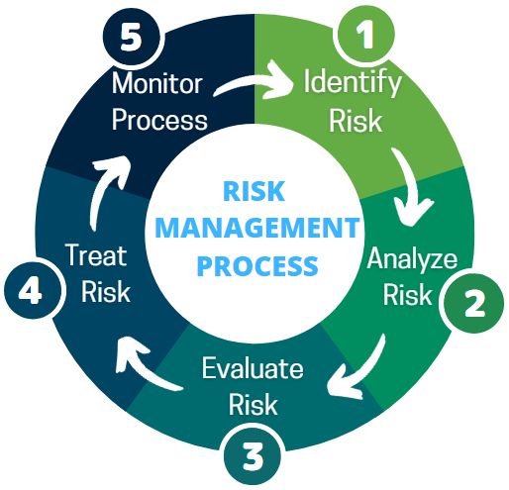

Why Risk Management Matters in IT Projects:
- Uncertainty and Complexity: IT projects often involve complex systems, emerging technologies, and dynamic environments, leading to inherent uncertainty and complexity. Effective risk management helps teams anticipate potential challenges, identify vulnerabilities, and prepare contingency plans to navigate uncertainty and mitigate risks proactively.
- Protecting Investments: IT projects typically require substantial investments of time, resources, and capital. By identifying and addressing risks early in the project lifecycle, organizations can protect their investments and minimize the likelihood of costly delays, budget overruns, or project failures.
- Ensuring Project Success: Risk management is essential for ensuring project success by maximizing the likelihood of achieving project objectives within scope, schedule, and budget constraints. By addressing risks systematically and strategically, project teams can mitigate threats, capitalize on opportunities, and deliver value to stakeholders with confidence.

Key Principles of IT Risk Management:
- Identify Risks: The first step in effective risk management is to identify and document potential risks that could impact the project's success. This involves brainstorming sessions, risk registers, historical data analysis, and input from stakeholders to capture a comprehensive list of risks.
- Assess Risks: Once risks are identified, they must be assessed to determine their likelihood and potential impact on project objectives. Qualitative and quantitative risk assessment techniques, such as probability and impact analysis, risk scoring, and risk prioritization, help teams prioritize risks and allocate resources accordingly.
- Mitigate Risks: After assessing risks, the next step is to develop and implement risk mitigation strategies to reduce the likelihood or impact of identified risks. Mitigation strategies may include risk avoidance, risk transfer, risk reduction, or risk acceptance, depending on the nature and severity of the risk.
- Monitor and Control Risks: Risk management is an ongoing process that requires continuous monitoring and control throughout the project lifecycle. Regular risk reviews, status updates, and performance metrics help teams track the effectiveness of mitigation measures, identify new risks, and adapt their strategies as needed to ensure project success.

Best Practices for IT Risk Management:
- Engage Stakeholders: Involve key stakeholders, including project sponsors, clients, end-users, and subject matter experts, in the risk management process to ensure alignment of priorities, expectations, and risk tolerance levels.
- Utilize Tools and Techniques: Leverage risk management tools and techniques, such as risk registers, risk matrices, risk workshops, and scenario analysis, to facilitate the identification, assessment, and mitigation of risks effectively.
- Promote a Culture of Risk Awareness: Foster a culture of risk awareness and accountability within the project team by encouraging open communication, sharing lessons learned, and recognizing proactive risk management efforts.
- Stay Agile and Adaptive: Embrace agility and adaptability in risk management to respond quickly to changing circumstances, emerging threats, and evolving project requirements. Iterative development cycles and continuous feedback loops enable teams to address risks iteratively and make course corrections as needed.

Final Thoughts
In conclusion, effective risk management is a critical component of successful IT project management. By proactively identifying, assessing, and mitigating risks, organizations can minimize threats, capitalize on opportunities, and deliver value to stakeholders with confidence and resilience. Embracing risk management as an integral part of the project lifecycle empowers teams to navigate the complexities of IT projects and achieve their goals with greater certainty and success.

#ITProjectManagement #RiskManagement #ProjectRisk #AgileProjectManagement #RiskMitigation #ProjectPlanning #StakeholderEngagement #RiskAssessment #ProjectSuccess #TechLeadership #ProjectStrategy #RiskMonitoring #ProjectExecution #ContinuousImprovement #RiskManagementStrategies

