Job Seekers Beware: How to Spot and Avoid LinkedIn Job Scams
Published on 15 May 2025 at 14:17
By Kimberly Wiethoff
LinkedIn is the world’s largest professional network, used by over 850 million people—and by 87% of job seekers during their job search. But where opportunity thrives, so do threats. LinkedIn job scams have surged by over 30% since 2020, preying on professionals' hopes, urgency, and trust. In today’s competitive job market, LinkedIn is an essential tool for building your professional brand, networking with employers, and discovering new opportunities. Unfortunately, it's also become a hunting ground for scammers who prey on job seekers' trust, hope, and urgency.
These bad actors impersonate recruiters, fabricate roles at recognizable companies, and create believable but fake hiring processes—all to steal your personal information, scam you out of money, or worse.
This blog post distills key insights from my recent presentation and equips you to recognize, avoid, and report scams while protecting your identity and career.
Here’s what every job seeker should know to stay safe on LinkedIn.

🚩 Common LinkedIn Job Scams
1. Fake Recruiters
Scammers create polished LinkedIn profiles using stolen photos and job titles like "Talent Acquisition Partner at Google." They reach out with messages about high-paying remote roles that sound too good to pass up.
2. Phony Job Offers
You may be offered a job after a quick chat via WhatsApp, Telegram, or email—no video interview, no resume review. These scams rely on urgency and vague job descriptions to keep you from asking too many questions.
3. Phishing Links
You’re asked to “apply” on an external site that looks like a real company’s portal but is actually designed to steal your information, including:
- Social Security Number
- Bank account details
- Address and phone number
4. Check Scams or Equipment Fees
Scammers send a fake check to “buy home office equipment” and ask you to send back a portion. The check bounces, and you’re left owing the bank. Others may ask you to pay for background checks, onboarding fees, or "certifications."

🎭 The Fake Recruiter Playbook
Scammers carefully construct LinkedIn personas that look legitimate but are anything but. Here’s what a fake recruiter often looks like:
- Polished profile photo (usually stolen)
- Impressive job title from a well-known company
- Few mutual connections
- Recently created profile
- Grammar issues in messages or summaries
They reach out with vague yet enticing job offers—typically high-paying, remote, and urgently hiring.
🛑 Red Flags to Watch For
🚩 Too-Good-To-Be-True Offers
- Unusually high salary for the role
- Immediate remote work
- No formal interviews or background checks
- Vague job descriptions with low requirements
🛑 Bonus Red Flag: “Please Update Your Resume This Way”
Another manipulative tactic scammers use is asking you to revise or reformat your resume using a suspicious template or service—often under the pretense of “helping you get hired.”
They may say things like:
- “Your resume needs to be in our company format.”
- “Please use this link to re-upload your resume with updated keywords.”
- “Our system only accepts resumes through this third-party portal.”
Why it's suspicious:
Your resume is likely already strong and optimized. This request is often a trick to harvest personal details or to lure you into uploading your resume to a fraudulent website that will use your information for identity theft or phishing attacks.
Tip:
Never upload your resume to unverified portals or use templates sent by someone you haven’t confirmed is a legitimate recruiter. If in doubt, ask to apply through the official company careers page.

🎣 Phishing Tactics to Steal Your Data
Scammers mimic legitimate company websites and job portals. Watch out for:
- URLs with slight misspellings (e.g., amaz0n-careers.net)
- Early requests for sensitive info like SSNs or banking info
- Resume uploads through unsecured third-party portals
- Attachments disguised as job descriptions (may contain malware)

💸 Financial Scam Flow
- Fake job offer with minimal screening
- Fake check sent to “buy equipment”
- Request to return funds or buy from “approved vendors”
- Check bounces, and you’re financially liable
⚠️ No real employer will send you money and ask for some back.

📱 Red Flags in Communication Channels
- Recruiters moving the conversation to Telegram or WhatsApp
- Use of personal email addresses (e.g., @gmail.com)
- Text-only interviews—no video, no call
- Unsolicited offers for jobs you never applied for
Legit recruiters typically stay on LinkedIn or use verified company emails.

🔎 How to Vet Opportunities
- Inspect recruiter profiles – Look for work history, endorsements, and employee connections.
- Verify job listings – Check the company’s official careers page.
- Check URLs – Avoid clicking links with unusual domain names.
- Ask your network – Reach out to real employees to confirm legitimacy.

❓ Questions That Unmask Scammers
Ask specifics to test legitimacy:
- “Can you tell me about the team culture?”
- “What’s the next step in the interview process?”
- “What projects would I support in the first 90 days?”
- “Can we continue via video chat?”
Evasive or vague answers? That’s your cue to walk away.

🔐 When to Share Your Info (and When Not To)
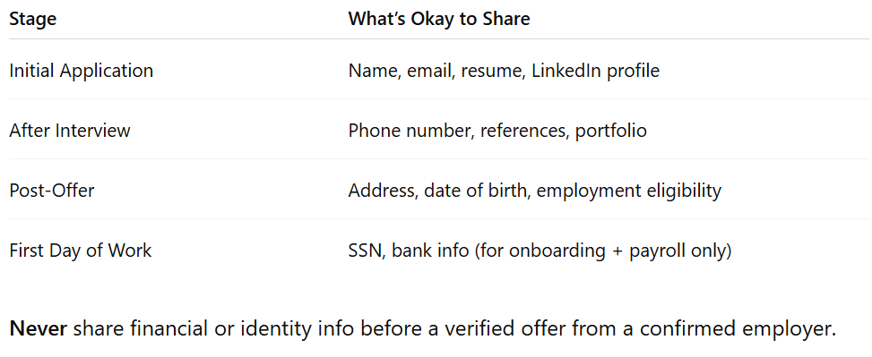

🧠 How to Protect Yourself
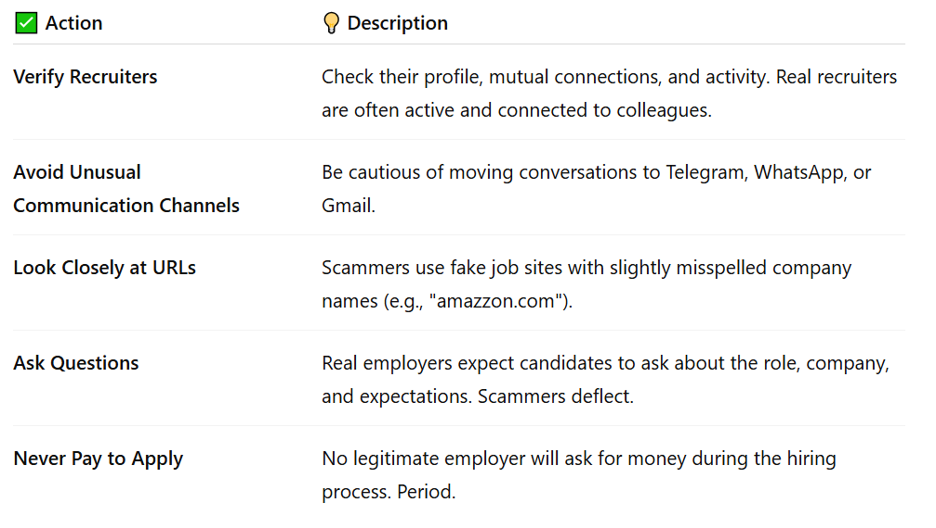

📣 What To Do If You Encounter a Scam
- On LinkedIn: Use the "Report" function on profiles and messages.
- To the FTC: https://reportfraud.ftc.gov
- To the FBI IC3: https://www.ic3.gov

🛡 Final Thoughts
If you're actively job searching, stay hopeful—but also stay vigilant. Scammers are getting more sophisticated, but with a few careful steps, you can avoid becoming a victim.
No matter how legitimate something seems, if it feels rushed, too easy, or suspicious—pause. Ask questions. Do your research. Your career is too important to fall for a shortcut that’s actually a trap.
In today’s job market, staying safe is just as important as staying visible.
#JobSearch #LinkedInScam #JobScamAwareness #CareerTips #HiringScams #RecruiterFraud #StaySafeOnline #OpenToWork #ATSJobs #CyberSecurity #ProfessionalNetworking #RemoteJobs

