Microsoft Dynamics 365 Project Operations vs Project for the Web: What’s the Difference?
Published on 6 May 2025 at 11:02
Author: Kimberly Wiethoff
Microsoft offers two robust solutions for managing projects—Dynamics 365 Project Operations and Project for the Web. While they both support project management, they serve different use cases, user types, and levels of complexity.
If you’re a project manager or PMO leader trying to decide which platform best suits your organization, this blog breaks down the core differences between the two and helps you align your choice with business needs.

What Is Microsoft Project for the Web?
Project for the Web is Microsoft’s lightweight, cloud-based project management tool designed for simple to moderately complex projects. Built on the Microsoft Power Platform, it integrates natively with Microsoft Teams and Office 365.
Key Features:
- Task planning with grid, board, and timeline views
- Drag-and-drop interface for scheduling and assignments
- Co-authoring and collaboration in Microsoft Teams
- Power Automate support for workflow creation
- Integration with Microsoft To Do and Outlook
Best For:
- Individual project managers or small teams
- Departmental-level initiatives
- Organizations seeking a simple, cost-effective solution
- Teams already heavily invested in Microsoft 365

What Is Dynamics 365 Project Operations?
Dynamics 365 Project Operations is a full-featured enterprise solution that combines project management, resource management, time tracking, financials, and CRM. It's ideal for professional services organizations and enterprises running large-scale, client-facing or internal projects.
Key Features:
- Advanced resource scheduling and capacity planning
- Project accounting, forecasting, and billing
- Timesheet and expense management
- Integration with D365 Sales, HR, and Finance
- Profitability tracking, contract management, and compliance
- Real-time analytics with embedded Power BI
Best For:
- Enterprise PMOs and consulting firms
- Complex, multi-phase or billable projects
- Businesses needing end-to-end project lifecycle management
- Organizations already using Dynamics 365 Finance or Sales

Comparison at a Glance
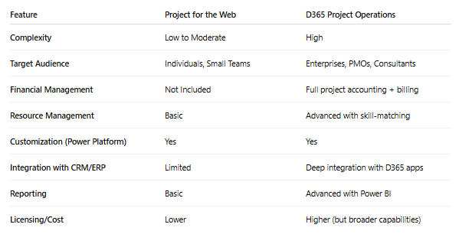

Which One Should You Choose?
- Choose Project for the Web if you need a quick, easy-to-use project tool without the complexity of enterprise financials or resource billing.
- Choose D365 Project Operations if you’re managing complex service-based work, need to tie in time and expense tracking, or require advanced forecasting, financials, and CRM integration.
In some organizations, both tools may be used side-by-side—with Project for the Web handling internal, tactical efforts and Project Operations managing client projects or enterprise-level initiatives.

Final Thoughts
Both Microsoft Project for the Web and Dynamics 365 Project Operations bring value—but in different ways. Understanding their strengths and limitations can help you build a project environment that scales with your organization and supports both agility and control. Choose wisely based on your team’s needs, project complexity, and business goals.

#MicrosoftDynamics365 #ProjectOperations #ProjectForTheWeb #ERPProjectManagement #ProjectManagementTools #MicrosoftProject #PMO #D365ProjectOps #Microsoft365 #ManagingProjectsTheAgileWay #EnterpriseProjectManagement #AgilePM

