Navigating Microsoft Azure Certifications: Which One Is Right for You?
Published on 3 June 2025 at 14:01
By Kimberly Wiethoff
As cloud computing continues to dominate the tech landscape, Microsoft Azure has become a top platform for organizations seeking secure, scalable, and cost-effective cloud solutions. Whether you're a beginner exploring cloud fundamentals or a seasoned IT professional specializing in architecture, security, or DevOps, Microsoft offers a certification path tailored to your career goals.
In this blog, we’ll break down the key Azure certifications—from fundamentals to expert level—so you can choose the one that aligns with your skills and aspirations.

🔹 1. Fundamentals Level

AZ-900: Microsoft Certified: Azure Fundamentals
- Who it's for: Beginners, business stakeholders, or non-technical professionals
- What it covers: Cloud concepts, Azure core services, pricing, SLAs, and compliance
- Why it matters: Provides a solid foundation for anyone new to Azure or cloud computing

AI-900: Azure AI Fundamentals
- Focus: AI workloads, machine learning, computer vision, NLP, and Azure AI services

DP-900: Azure Data Fundamentals
- Focus: Core data concepts, relational/non-relational data, analytics workloads

SC-900: Microsoft Security, Compliance, and Identity Fundamentals
- Focus: Security, compliance, identity concepts, and services in Microsoft solutions

🔹 2. Associate Level

AZ-104: Azure Administrator Associate
- Ideal for: IT professionals managing Azure resources, identities, and governance
- Key skills: Virtual networking, compute, storage, monitoring, and RBAC

AZ-204: Azure Developer Associate
- Ideal for: Developers building cloud applications and services
- Key skills: Azure SDKs, APIs, Azure Functions, containers, CI/CD

AZ-220: Azure IoT Developer Associate
- Focus: Edge devices, IoT solutions, data pipelines

DP-203: Azure Data Engineer Associate
- Focus: Data ingestion, transformation, and loading (ETL/ELT) using tools like Synapse and Data Factory

AI-102: Azure AI Engineer Associate
- Focus: Cognitive Services, Bot Framework, and ML model integration

SC-200, SC-300, SC-400: Security, Identity, and Information Protection
- SC-200: Security Operations Analyst
- SC-300: Identity and Access Administrator
- SC-400: Information Protection Administrator

🔹 3. Expert Level

AZ-305: Azure Solutions Architect Expert (Replaces AZ-303 & AZ-304)
- Who it's for: Senior architects and consultants designing end-to-end Azure solutions
- Key skills: Hybrid identity, compute, storage, security, governance, business continuity
Note: Requires prior experience or AZ-104 knowledge before attempting

AZ-400: Azure DevOps Engineer Expert
- Ideal for: Professionals with both development and operations knowledge
- Key skills: CI/CD, infrastructure as code, testing, monitoring, GitHub and Azure DevOps pipelines

🔹 4. Specialty Certifications
These validate deep expertise in niche areas:

AZ-500: Azure Security Engineer Associate
- Advanced security controls, threat protection, and incident response

AZ-720: Azure Support Engineer for Connectivity Specialty
- Troubleshooting hybrid cloud and network-related issues

AZ-800 & AZ-801: Administering Windows Server Hybrid Core Infrastructure
- Manage on-prem and Azure-integrated Windows Server environments

✅ How to Choose the Right Certification
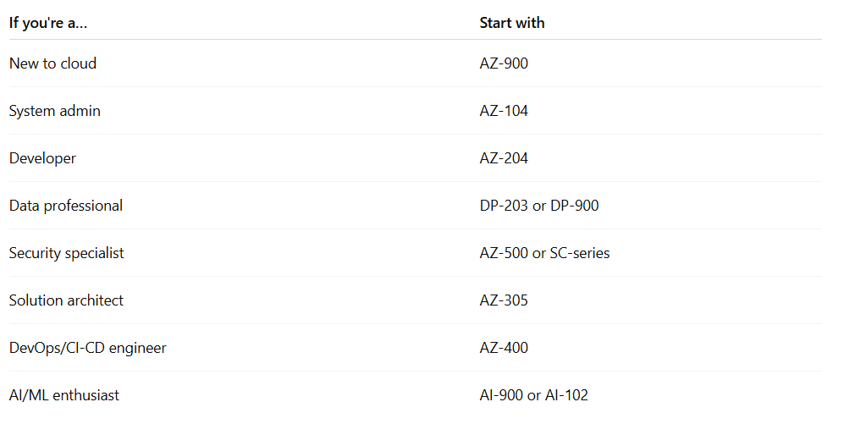

🧠 Final Thoughts
Microsoft Azure certifications offer a flexible roadmap whether you're entering the cloud industry or advancing in your current role. By investing in the right certification, you can showcase your expertise, stay competitive, and open doors to high-paying roles in a cloud-first world.

🔗 Useful Resources
- Microsoft Learn – Azure Certifications
- Free Azure Training Paths
- Exam Registration – Microsoft
Whether you're just starting out or advancing your cloud career, this blog is for you. Explore Microsoft Azure certification paths and share your journey using hashtags like #MicrosoftAzure, #AzureCertification, #CloudComputing, and #LearnAzure. If you're focused on specific roles, tag your progress with #AzureAdministrator, #AzureDeveloper, #AzureSolutionsArchitect, #AzureDevOps, #AIEngineer, or #SecurityEngineer. Stay motivated and connect with other professionals through #CloudSkills, #TechCareers, #Upskill, #ProfessionalDevelopment, and #CertificationsMatter. Let’s grow in the cloud—together. #ManagingProjectsTheAgileWay

